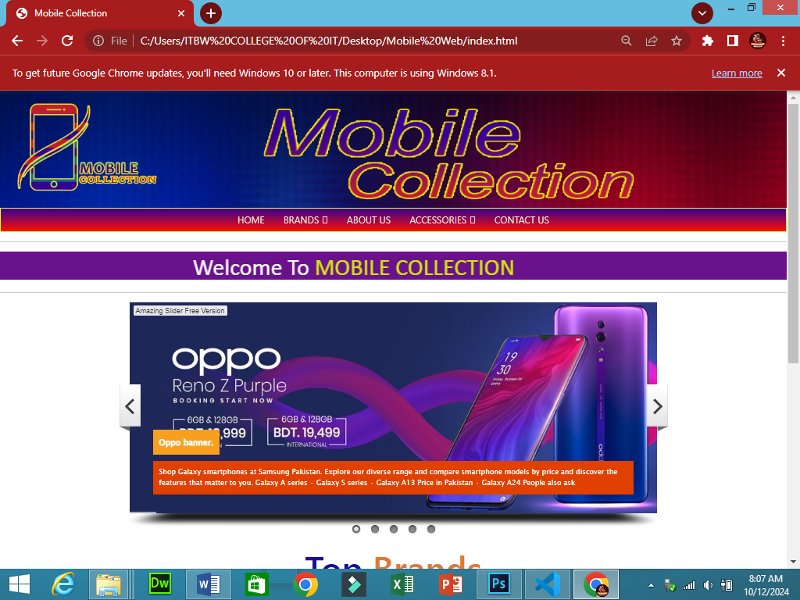

Home

`

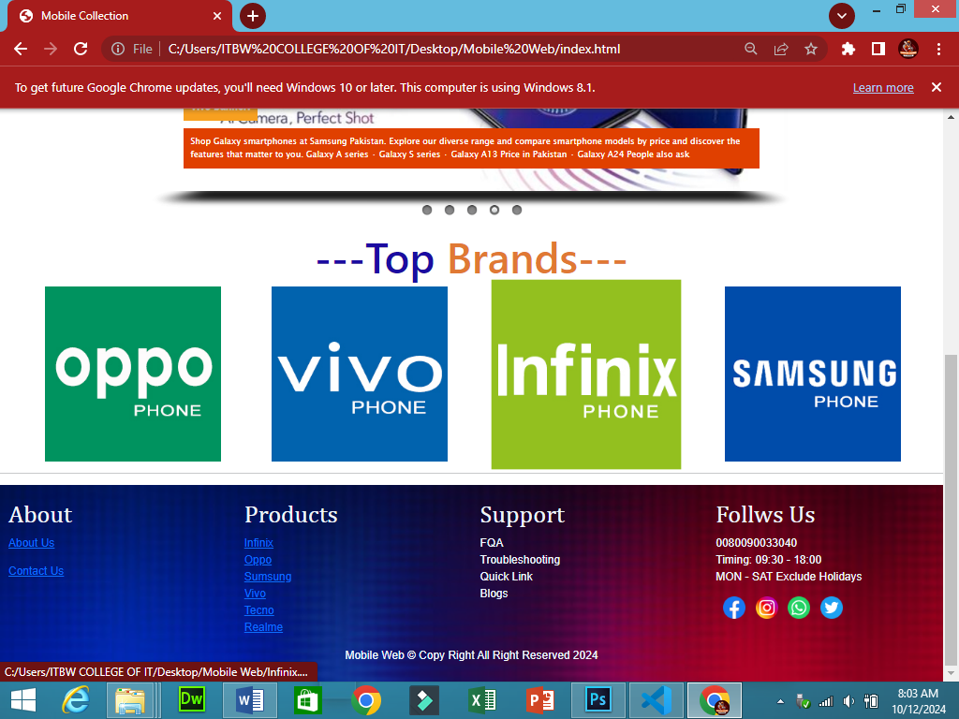



Brands

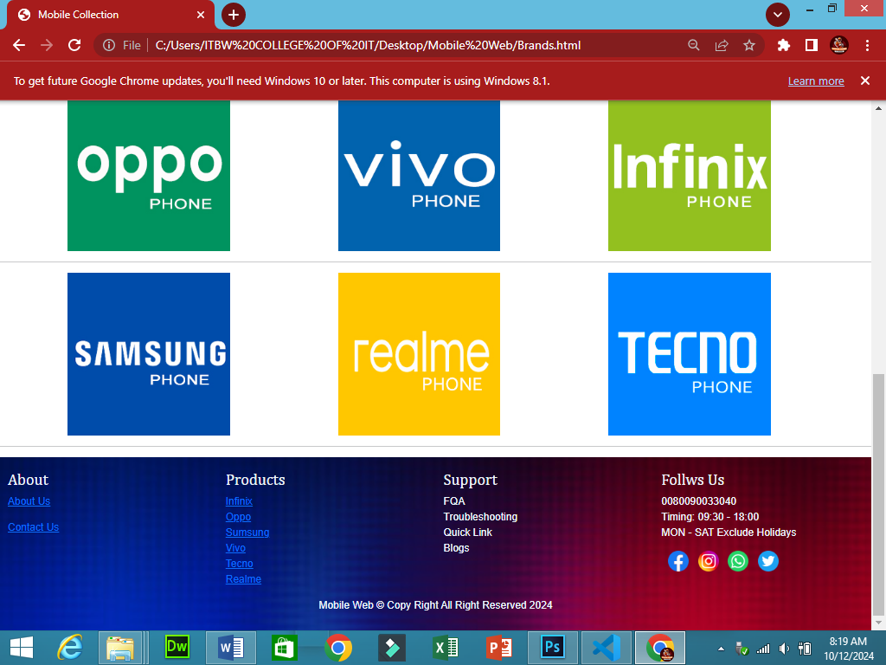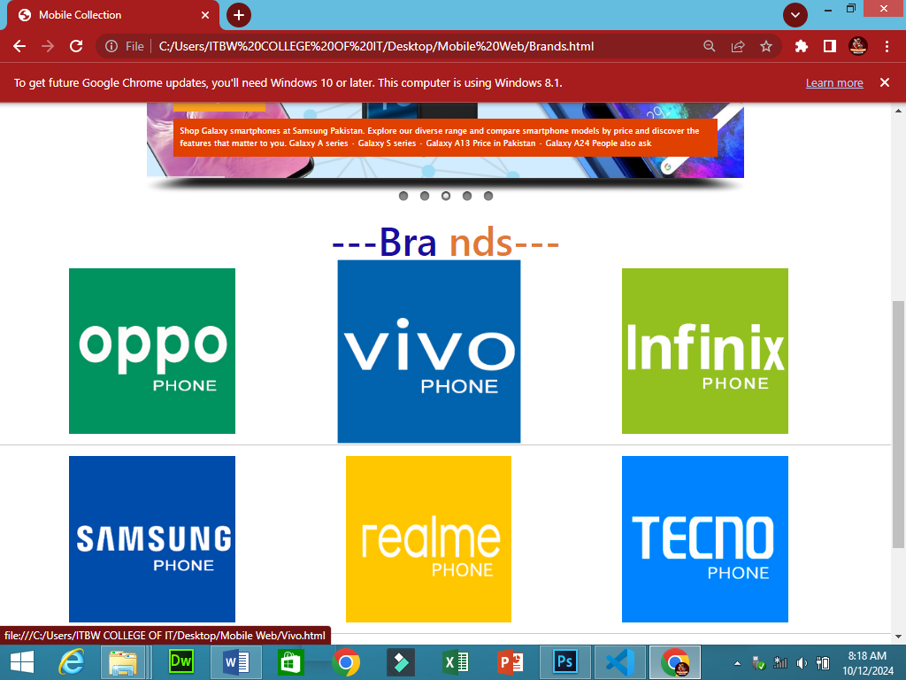



Infinix

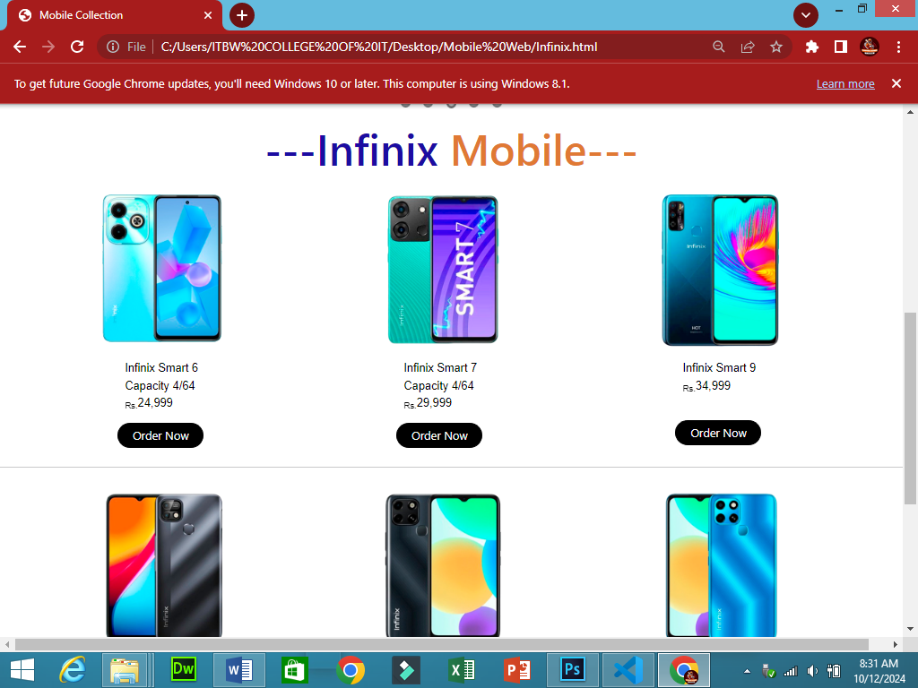

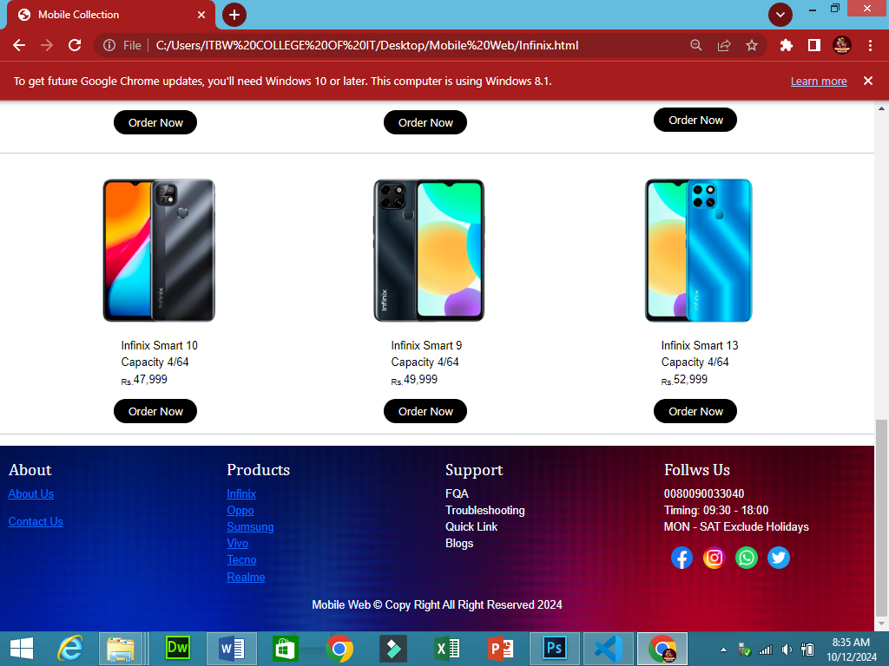



Oppo

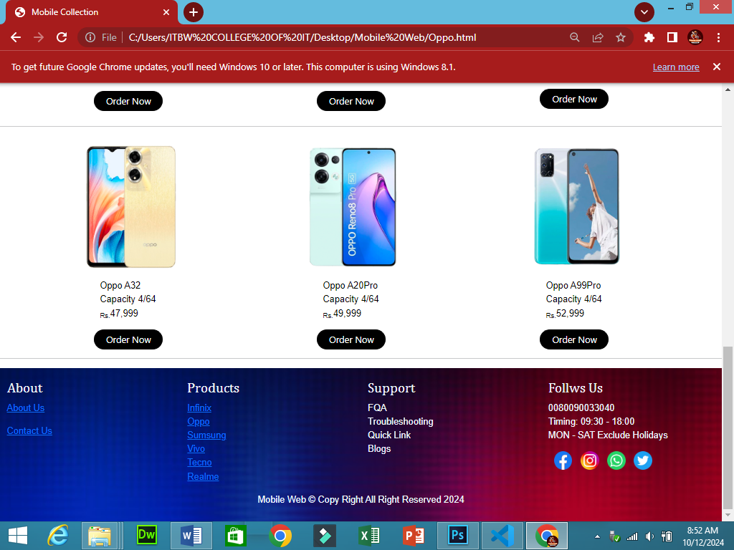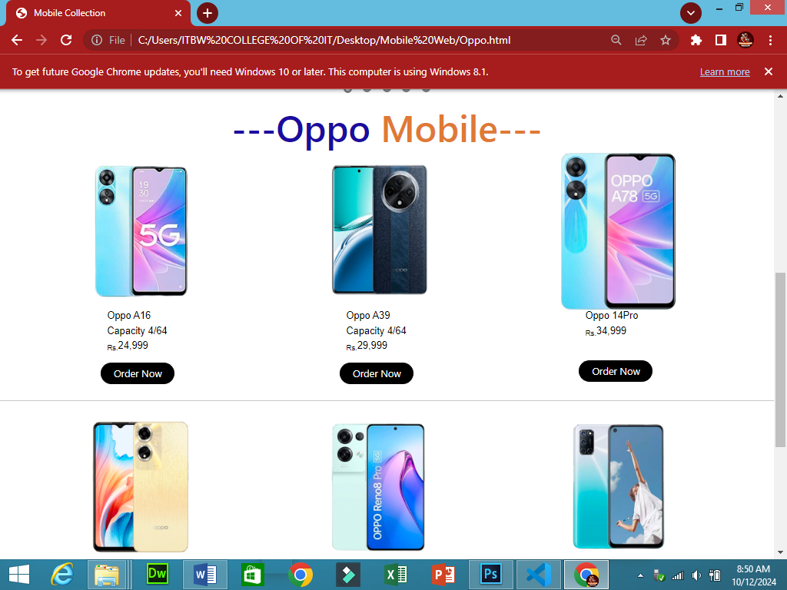



Sumsung

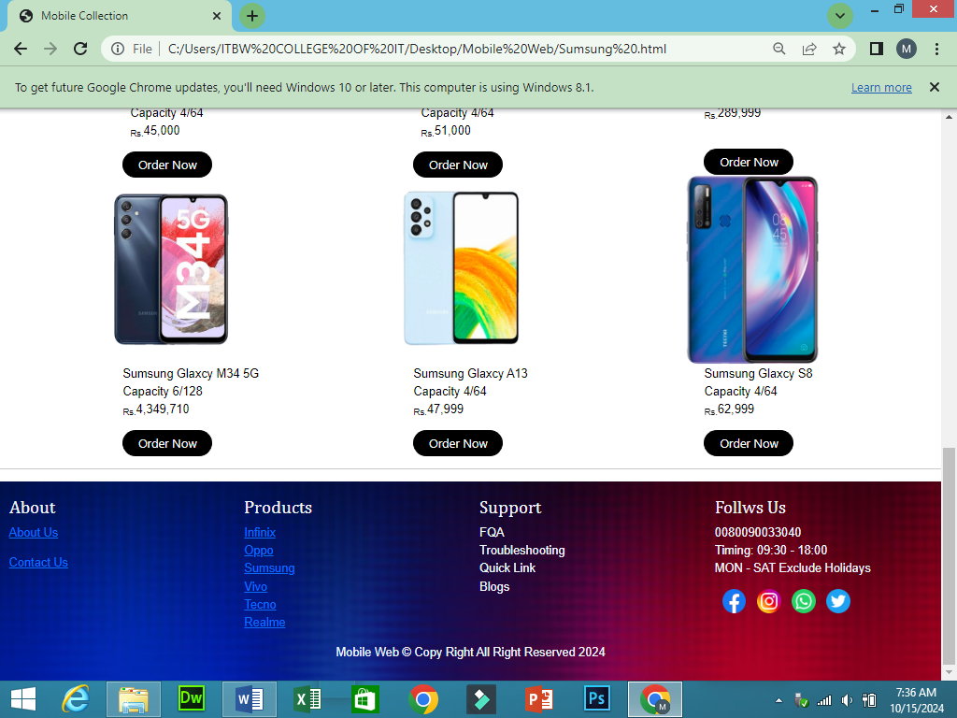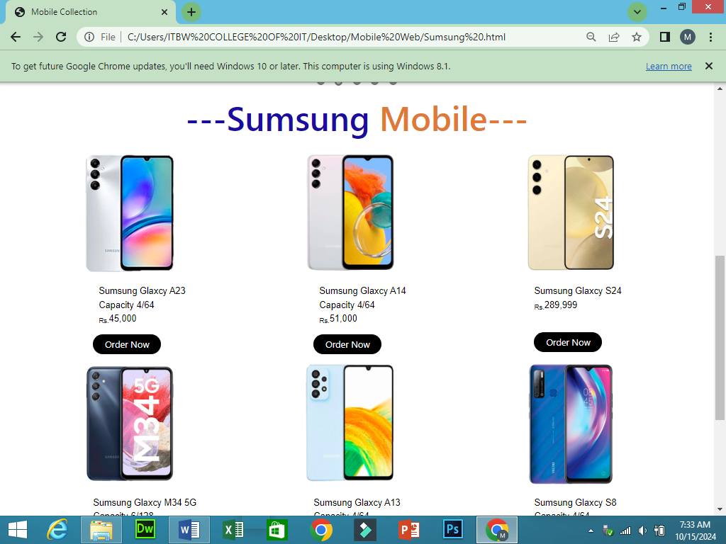

SUMSUNG



Vivo

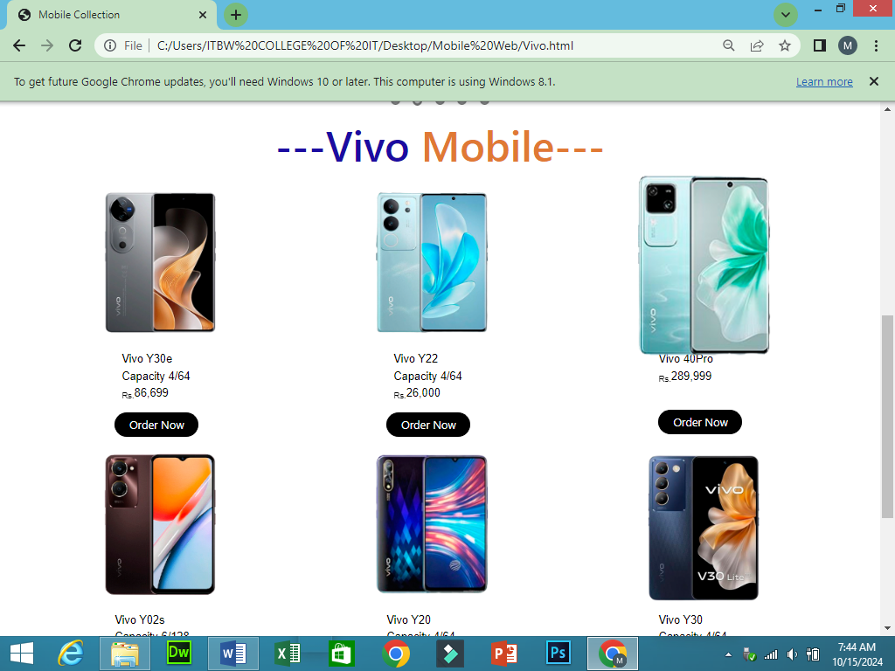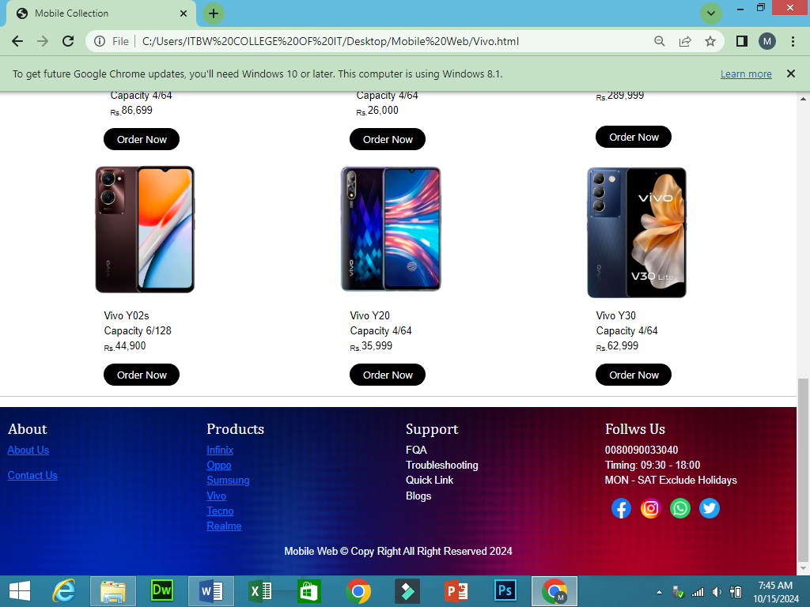



Tecno

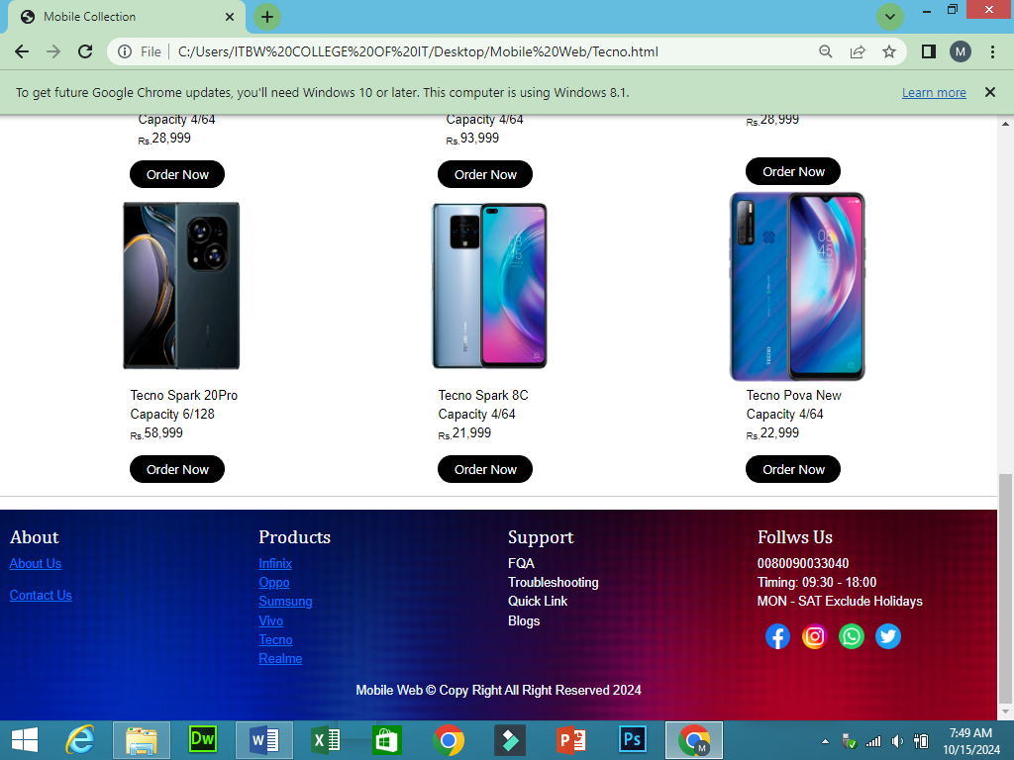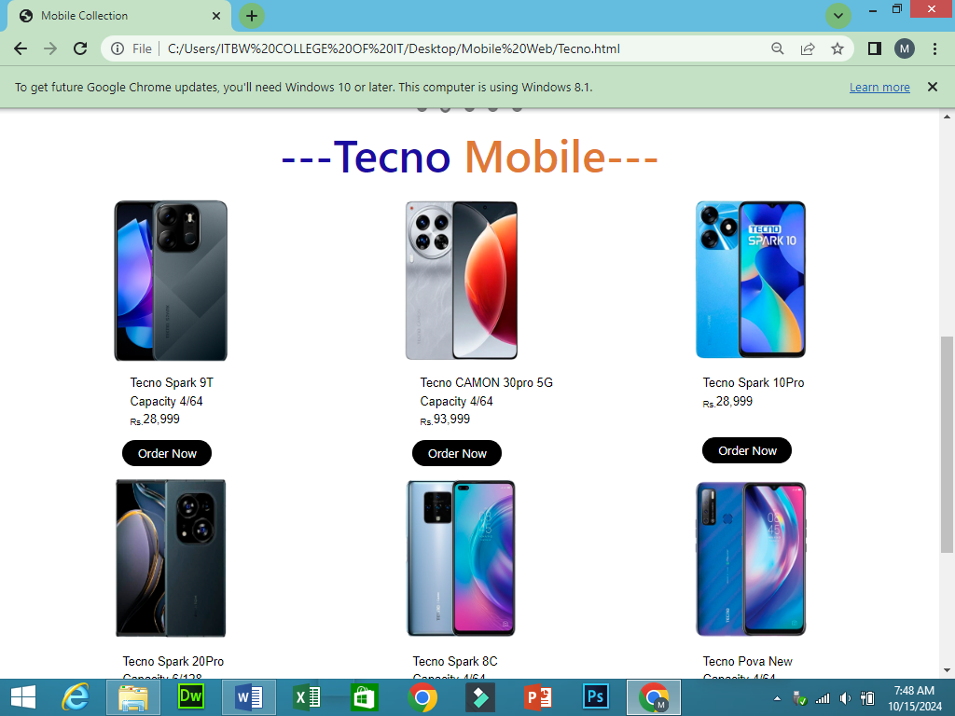



Realme

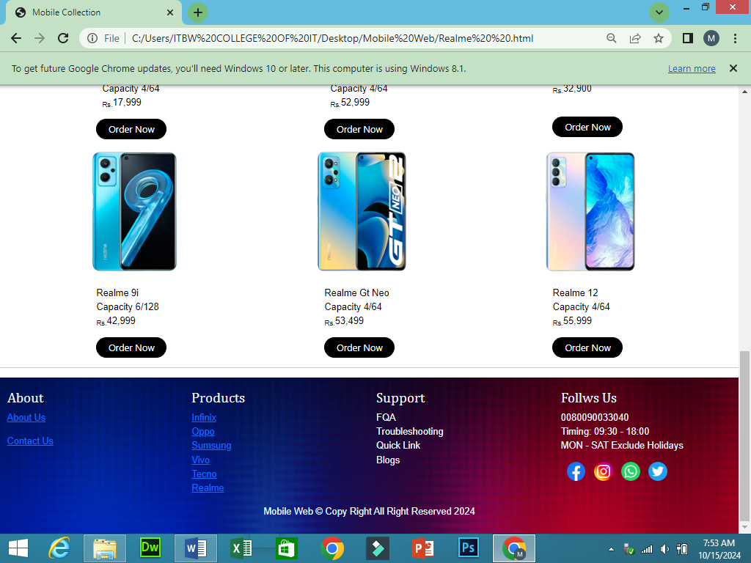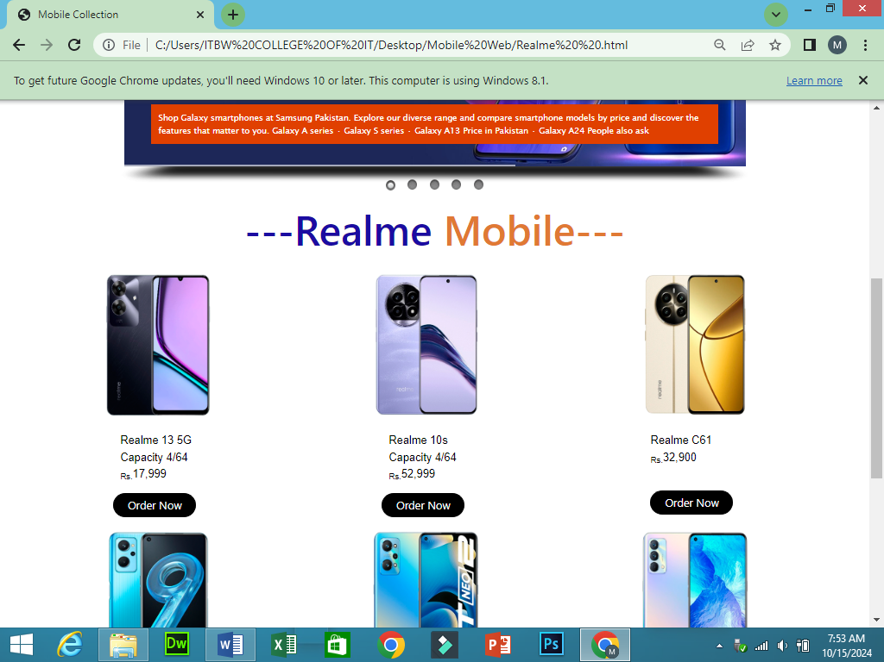



About Us

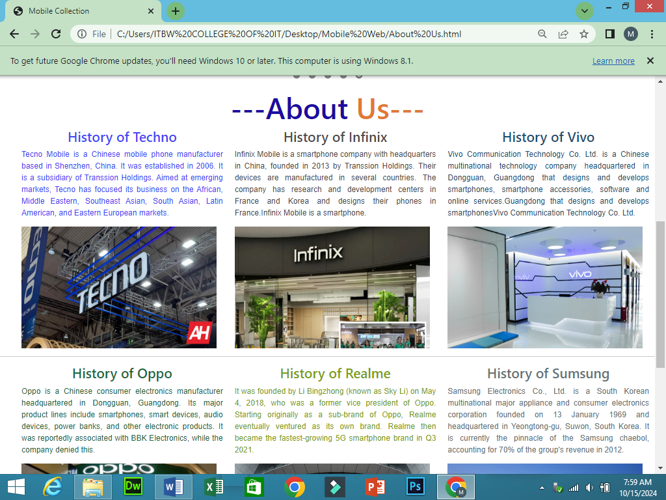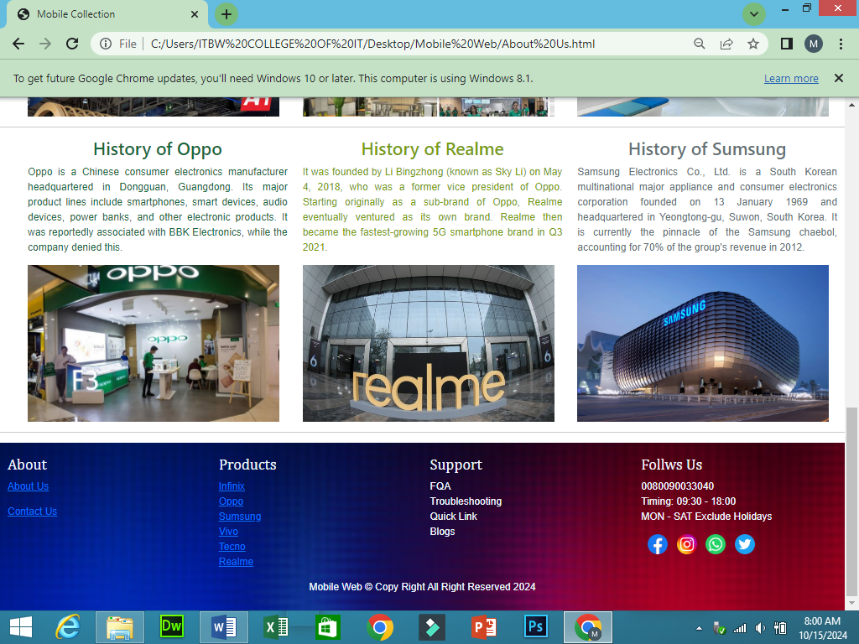



Adopter

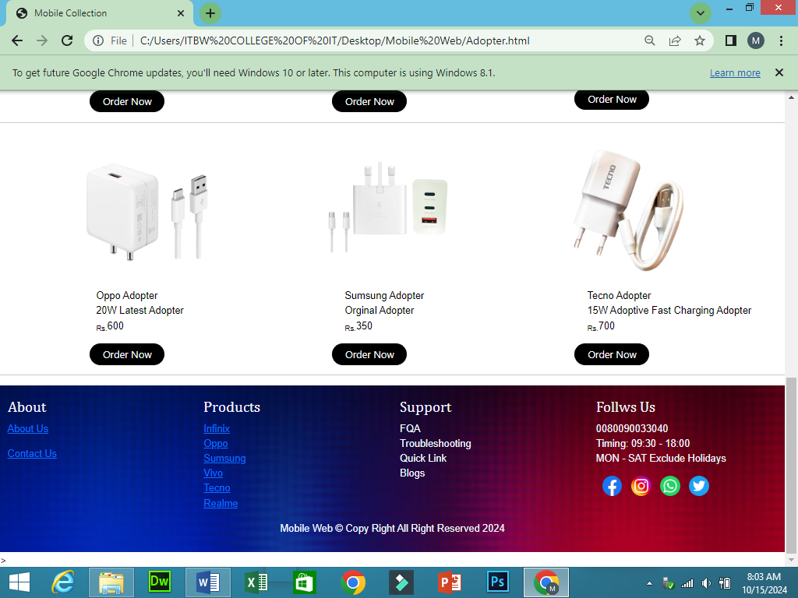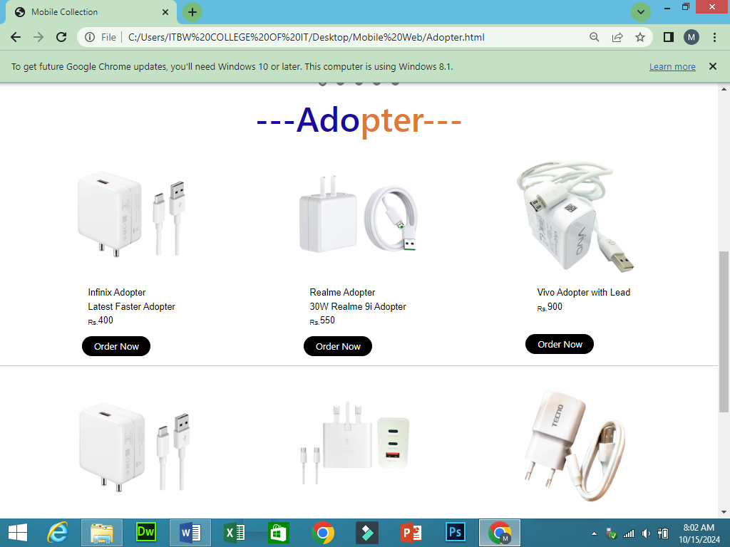



Back Cover

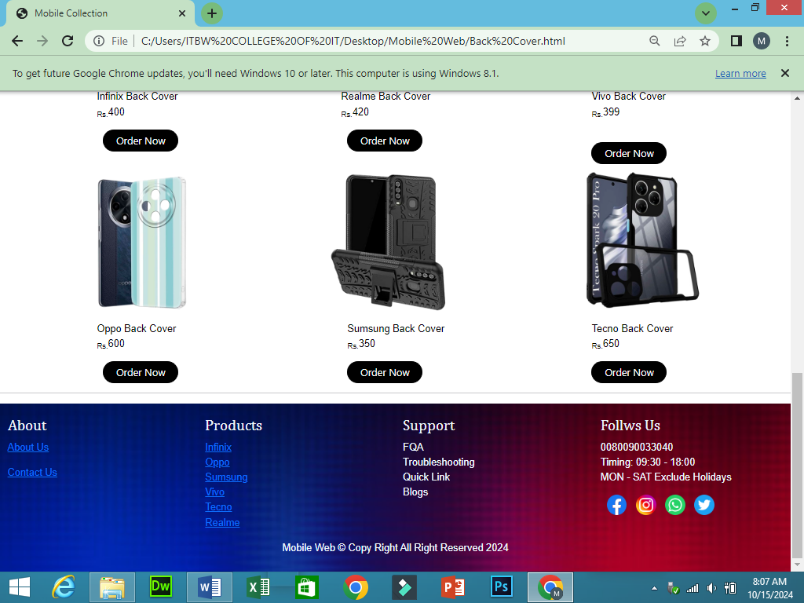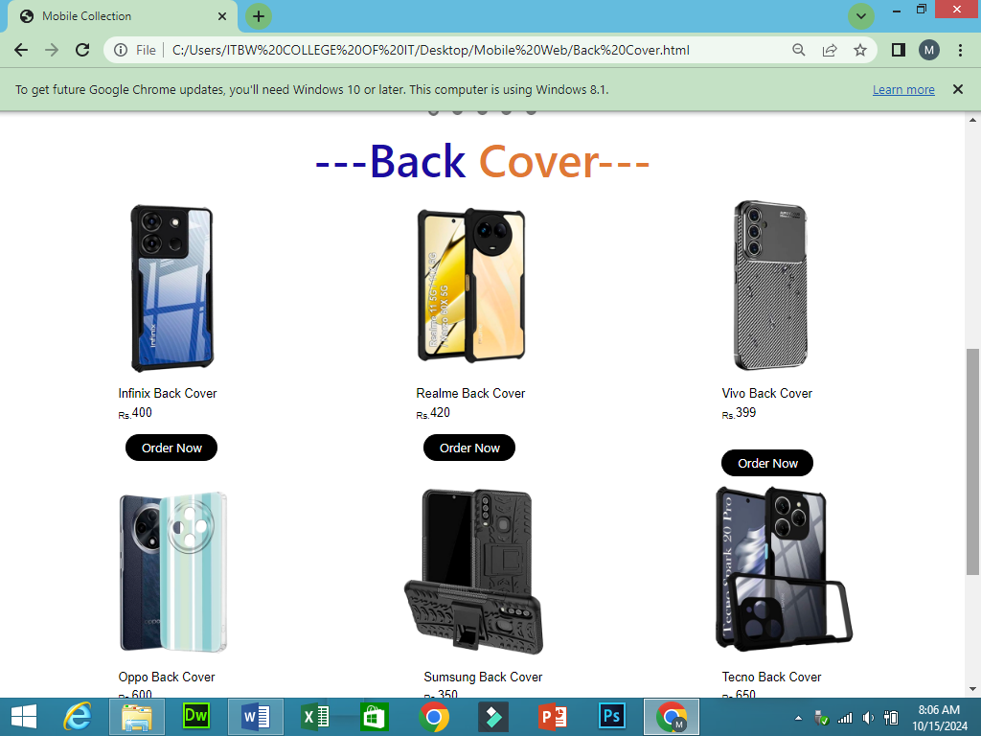



Contact Us

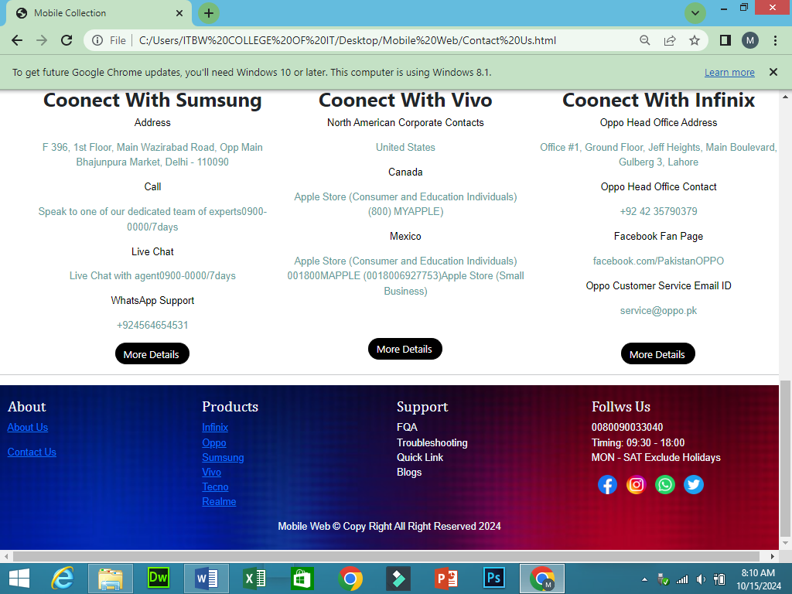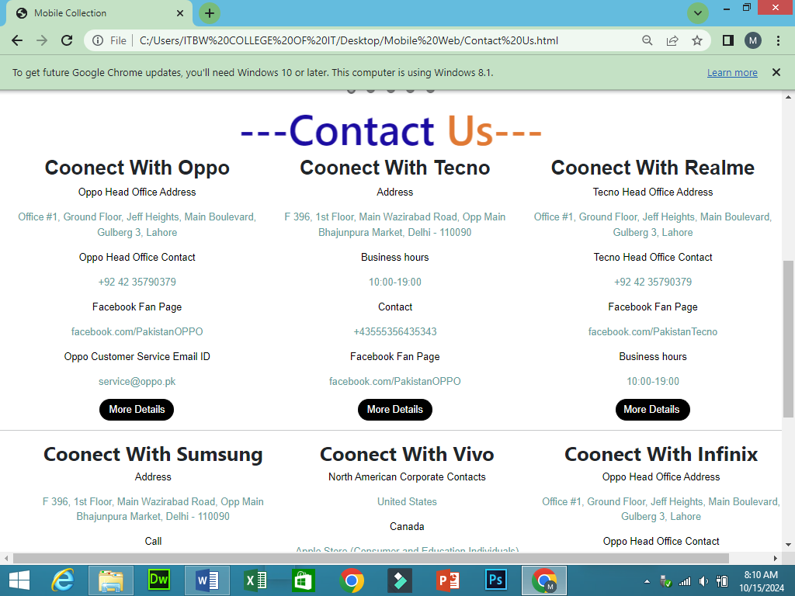

<!DOCTYPE html>

Index.html

<html>

    <head>

        <title>Mobile Collection</title>

        <link rel='stylesheet' href='css/style.css'>

        <script src="sliderengine/jquery.js"></script>

    <script src="sliderengine/amazingslider.js"></script>

    <link rel="stylesheet" type="text/css" href="sliderengine/amazingslider-1.css">

    <script src="sliderengine/initslider-1.js"></script>

<script src='js/script.js'></script>

<link href="https://cdn.jsdelivr.net/npm/bootstrap@5.3.3/dist/css/bootstrap.min.css" rel="stylesheet">

  <script src="https://cdn.jsdelivr.net/npm/bootstrap@5.3.3/dist/js/bootstrap.bundle.min.js"></script>

  <style>

    h4{

        color: rgb(239, 245, 250);font-family: Cambria, Cochin, Georgia, Times, 'Times New Roman', serif;font-size: 35px;

    }

    p{

      color: aliceblue;font-family: Arial, Helvetica, sans-serif;

      }

      .img:hover{

        transition: 2s;

        scale: 1.1;

      }

  </style>

    </head>

    <body>

        <!--Header-->

        <header style="background-image: url(Img/gradient\ \ 1.jpg);background-size: cover;">

            <img src="Img/300.png"/>

            <img src="Img/Mobile Collection  .png"/>

          </header>

          <!--Navber-->

          <nav id='menu'>

            <input type='checkbox' id='responsive-menu' onclick='updatemenu()'><label></label>

            <ul>

              <li><a href='index.html'>Home</a></li>

              <li><a class='dropdown-arrow' href='Brands.html'>Brands</a>

                <ul class='sub-menus'>

                  <li><a href='Infinix.html'>Infinix</a></li>

                  <li><a href='Oppo.html'>Oppo</a></li>

                  <li><a href='Sumsung .html'>Sumsung </a></li>

                  <li><a href='Vivo.html'>Vivo</a></li>

                  <li><a href='Tecno.html'>Tecno </a></li>

                  <li><a href='Realme  .html'>Realme </a></li>

                </ul>

              </li>

              <li><a href='About Us.html'>About Us</a></li>

              <li><a class='dropdown-arrow' href='index.html'>Accessories</a>

                <ul class='sub-menus'>

                  <li><a href='Adopter.html'>Adopter </a></li>

                  <li><a href='Back Cover.html'>Back Cover </a></li>

                </ul>

              </li>

              <li><a href='Contact Us.html'>Contact Us</a></li>

            </ul>

          </nav>

         <hr>

    <marquee style="background-color:rgb(105, 18, 139); height: 48px; "><h1 style="margin-top: 3px; font-family: 'Gill Sans', 'Gill Sans MT', Calibri, 'Trebuchet MS', sans-serif; color: white;">Welcome To <span style="font-family: 'Gill Sans', 'Gill Sans MT', Calibri, 'Trebuchet MS', sans-serif; color: rgb(215, 230, 14); ">MOBILE COLLECTION</h1></marquee>

    <hr>

         <!--Silider-->

         <div class="amazingslider-wrapper" id="amazingslider-wrapper-1" style="display:block;position:relative;max-width:900px;margin:0px auto 56px;">

          <div class="amazingslider" id="amazingslider-1" style="display:block;position:relative;margin:0 auto;">

              <ul class="amazingslider-slides" style="display:none;">

                  <li><img src="images/Oppo%20%20banner..jpg" alt="Oppo  banner."  title="Oppo  banner." data-description="Shop Galaxy smartphones at Samsung Pakistan. Explore our diverse range and compare smartphone models by price and discover the features that matter to you.

  ‎Galaxy A series · ‎Galaxy S series · ‎Galaxy A13 Price in Pakistan · ‎Galaxy A24

  People also ask" />

                  </li>

                  <li><img src="images/Realme%20banner..jpg" alt="Realme banner."  title="Realme banner." data-description="Shop Galaxy smartphones at Samsung Pakistan. Explore our diverse range and compare smartphone models by price and discover the features that matter to you.

  ‎Galaxy A series · ‎Galaxy S series · ‎Galaxy A13 Price in Pakistan · ‎Galaxy A24

  People also ask" />

                  </li>

                  <li><img src="images/Sumsung%20banner..jpg" alt="Sumsung banner."  title="Sumsung banner." data-description="Shop Galaxy smartphones at Samsung Pakistan. Explore our diverse range and compare smartphone models by price and discover the features that matter to you.

  ‎Galaxy A series · ‎Galaxy S series · ‎Galaxy A13 Price in Pakistan · ‎Galaxy A24

  People also ask" />

                  </li>

                  <li><img src="images/Vivo%20banner..jpg" alt="Vivo banner."  title="Vivo banner." data-description="Shop Galaxy smartphones at Samsung Pakistan. Explore our diverse range and compare smartphone models by price and discover the features that matter to you.

  ‎Galaxy A series · ‎Galaxy S series · ‎Galaxy A13 Price in Pakistan · ‎Galaxy A24

  People also ask" />

                  </li>

                  <li><img src="images/Infinix%20%20banner..jpg" alt="Infinix  banner."  title="Infinix  banner." data-description="Shop Galaxy smartphones at Samsung Pakistan. Explore our diverse range and compare smartphone models by price and discover the features that matter to you.

  ‎Galaxy A series · ‎Galaxy S series · ‎Galaxy A13 Price in Pakistan · ‎Galaxy A24

  People also ask" />

                  </li>

              </ul>

              <ul class="amazingslider-thumbnails" style="display:none;">

                  <li><img src="images/Oppo%20%20banner.-tn.jpg" alt="Oppo  banner." title="Oppo  banner." /></li>

                  <li><img src="images/Realme%20banner.-tn.jpg" alt="Realme banner." title="Realme banner." /></li>

                  <li><img src="images/Sumsung%20banner.-tn.jpg" alt="Sumsung banner." title="Sumsung banner." /></li>

                  <li><img src="images/Vivo%20banner.-tn.jpg" alt="Vivo banner." title="Vivo banner." /></li>

                  <li><img src="images/Infinix%20%20banner.-tn.jpg" alt="Infinix  banner." title="Infinix  banner." /></li>

              </ul>

          <div class="amazingslider-engine"><a href="http://amazingslider.com" title="JavaScript Image Slideshow">JavaScript Image Slideshow</a></div>

          </div>

      </div>

     <!--Section-->

     <h1 class="img" style="text-align: center;color: rgb(27, 12, 161);font-size: 60px;">---Top <span style="color: rgb(224, 121, 52);">Brands---</h1></span>

     <div class="container-fluid">

      <div class="row" style="margin-left: 40px;">

        <div class="col-sm-3 col-md-3 col-lg-3">

       <a href="Oppo.html"><img class="img" src="Img/Oppo  logo.jpg"/></a>

        </div>

        <div class="col-sm-3 col-md-3 col-lg-3">

        <a href="Vivo.html"><img class="img" src="Img/Vivo logo.jpg"/></a>

        </div>

        <div class="col-sm-3 col-md-3 col-lg-3">

          <a href="Infinix.html"><img class="img" src="Img/Infinix  logo.jpg"/></a>

        </div>

        <div class="col-sm-3 col-md-3 col-lg-3">

          <a href="Sumsung .html"><img class="img" src="Img/Sumsung logo.jpg"/></a>

        </div>

    </div>

  </div>

  <hr>

  <!--Footer-->

  <footer style="background-image:url(Img/gradient\ \ 1.jpg);background-size: cover; padding-top: 20px; padding-bottom: 10px;">

    <div class ="container-fluid">

      <div class="row">

        <div class="col-sm-3 col-md-3 col-lg-3">

   <h4>About </h4>

   <p><a href="About Us.html"> About Us</a></p>

   <p><a href="Contact Us.html"> Contact Us </p></a>

        </div>

        <div class="col-sm-3 col-md-3 col-lg-3">

   <h4>Products</h4>

 <p><a href="Infinix.html" >Infinix</a><br>

 <a href="Oppo.html" >Oppo</a><br>

 <a href="Sumsung .html" >Sumsung</a><br>

 <a href="Vivo.html" >Vivo</a><br>

 <a href="Tecno.html" >Tecno</a><br>

 <a href="Realme  .html" >Realme</a><br>

 </p>

        </div>

        <div class="col-sm-3 col-md-3 col-lg-3">

          <h4>Support</h4>

          <p>FQA <br> Troubleshooting <br>Quick Link <br>Blogs</p>

        </div>

        <div class="col-sm-3 ol-md-3 col-lg-3">

         <h4>Follws Us</h4>

         <p>0080090033040 <br>

          Timing: 09:30 - 18:00<br> MON - SAT

          Exclude Holidays

          </p>

         <a href="https://www.facebook.com/"><img style="margin-left: 10px;" src="Img/5296499_fb_facebook_facebook logo_icon.png"/></a>

         <a href="https://www.instagram.com/"> <img style="margin-left: 10px;" src="Img/3225191_app_instagram_logo_media_popular_icon.png"/></a>

          <a href="https://web.whatsapp.com/"><img style="margin-left: 10px;" src="Img/3225179_app_logo_media_popular_social_icon.png"/></a>

          <a href="https://x.com/?lang=en&mx=2"><img style="margin-left: 10px;" src="Img/3225183_app_logo_media_popular_social_icon.png"/></a>

        </div>

    </div>

  </div>

    <p style="text-align: center;">Mobile Web &copy; Copy Right All Right Reserved 2024</p>

  </footer>

    </body>

</html>

Brands.html

<!DOCTYPE html>

<html>

    <head>

        <title>Mobile Collection</title>

        <link rel='stylesheet' href='css/style.css'>

        <script src="sliderengine/jquery.js"></script>

    <script src="sliderengine/amazingslider.js"></script>

    <link rel="stylesheet" type="text/css" href="sliderengine/amazingslider-1.css">

    <script src="sliderengine/initslider-1.js"></script>

<script src='js/script.js'></script>

<link href="https://cdn.jsdelivr.net/npm/bootstrap@5.3.3/dist/css/bootstrap.min.css" rel="stylesheet">

  <script src="https://cdn.jsdelivr.net/npm/bootstrap@5.3.3/dist/js/bootstrap.bundle.min.js"></script>

  <style>

    h4{

        color: rgb(239, 245, 250);font-family: Cambria, Cochin, Georgia, Times, 'Times New Roman', serif;

    }

    p{

      color: aliceblue;font-family: Arial, Helvetica, sans-serif;

      }

      .img:hover{

        transition: 2s;

        scale: 1.1;

      }

  </style>

    </head>

    <body>

        <!--Header-->

        <header style="background-image: url(Img/gradient\ \ 1.jpg);background-size: cover;">

            <img src="Img/300.png"/>

            <img src="Img/Mobile Collection  .png"/>

          </header>

          <!--Navber-->

          <nav id='menu'>

            <input type='checkbox' id='responsive-menu' onclick='updatemenu()'><label></label>

            <ul>

              <li><a href='index.html'>Home</a></li>

              <li><a class='dropdown-arrow' href='Brands.html'>Brands</a>

                <ul class='sub-menus'>

                  <li><a href='Infinix.html'>Infinix</a></li>

                  <li><a href='Oppo.html'>Oppo</a></li>

                  <li><a href='Sumsung .html'>Sumsung </a></li>

                  <li><a href='Vivo.html'>Vivo</a></li>

                  <li><a href='Tecno.html'>Tecno </a></li>

                  <li><a href='Realme  .html'>Realme </a></li>

                </ul>

              </li>

              <li><a href='About Us.html'>About Us</a></li>

              <li><a class='dropdown-arrow' href='index.html'>Accessories</a>

                <ul class='sub-menus'>

                  <li><a href='Adopter.html'>Adopter </a></li>

                  <li><a href='Back Cover.html'>Back Cover </a></li>

                </ul>

              </li>

              <li><a href='Contact Us.html'>Contact Us</a></li>

            </ul>

          </nav>

          <hr>

          <marquee style="background-color:rgb(105, 18, 139); height: 48px; "><h1 style="margin-top: 3px; font-family: 'Gill Sans', 'Gill Sans MT', Calibri, 'Trebuchet MS', sans-serif; color: white;">Welcome To <span style="font-family: 'Gill Sans', 'Gill Sans MT', Calibri, 'Trebuchet MS', sans-serif; color: rgb(215, 230, 14); ">MOBILE COLLECTION</h1></marquee>

          <hr>

               <!--Silider-->

         <div class="amazingslider-wrapper" id="amazingslider-wrapper-1" style="display:block;position:relative;max-width:900px;margin:0px auto 56px;">

          <div class="amazingslider" id="amazingslider-1" style="display:block;position:relative;margin:0 auto;">

              <ul class="amazingslider-slides" style="display:none;">

                  <li><img src="images/Oppo%20%20banner..jpg" alt="Oppo  banner."  title="Oppo  banner." data-description="Shop Galaxy smartphones at Samsung Pakistan. Explore our diverse range and compare smartphone models by price and discover the features that matter to you.

  ‎Galaxy A series · ‎Galaxy S series · ‎Galaxy A13 Price in Pakistan · ‎Galaxy A24

  People also ask" />

                  </li>

                  <li><img src="images/Realme%20banner..jpg" alt="Realme banner."  title="Realme banner." data-description="Shop Galaxy smartphones at Samsung Pakistan. Explore our diverse range and compare smartphone models by price and discover the features that matter to you.

  ‎Galaxy A series · ‎Galaxy S series · ‎Galaxy A13 Price in Pakistan · ‎Galaxy A24

  People also ask" />

                  </li>

                  <li><img src="images/Sumsung%20banner..jpg" alt="Sumsung banner."  title="Sumsung banner." data-description="Shop Galaxy smartphones at Samsung Pakistan. Explore our diverse range and compare smartphone models by price and discover the features that matter to you.

  ‎Galaxy A series · ‎Galaxy S series · ‎Galaxy A13 Price in Pakistan · ‎Galaxy A24

  People also ask" />

                  </li>

                  <li><img src="images/Vivo%20banner..jpg" alt="Vivo banner."  title="Vivo banner." data-description="Shop Galaxy smartphones at Samsung Pakistan. Explore our diverse range and compare smartphone models by price and discover the features that matter to you.

  ‎Galaxy A series · ‎Galaxy S series · ‎Galaxy A13 Price in Pakistan · ‎Galaxy A24

  People also ask" />

                  </li>

                  <li><img src="images/Infinix%20%20banner..jpg" alt="Infinix  banner."  title="Infinix  banner." data-description="Shop Galaxy smartphones at Samsung Pakistan. Explore our diverse range and compare smartphone models by price and discover the features that matter to you.

  ‎Galaxy A series · ‎Galaxy S series · ‎Galaxy A13 Price in Pakistan · ‎Galaxy A24

  People also ask" />

                  </li>

              </ul>

              <ul class="amazingslider-thumbnails" style="display:none;">

                  <li><img src="images/Oppo%20%20banner.-tn.jpg" alt="Oppo  banner." title="Oppo  banner." /></li>

                  <li><img src="images/Realme%20banner.-tn.jpg" alt="Realme banner." title="Realme banner." /></li>

                  <li><img src="images/Sumsung%20banner.-tn.jpg" alt="Sumsung banner." title="Sumsung banner." /></li>

                  <li><img src="images/Vivo%20banner.-tn.jpg" alt="Vivo banner." title="Vivo banner." /></li>

                  <li><img src="images/Infinix%20%20banner.-tn.jpg" alt="Infinix  banner." title="Infinix  banner." /></li>

              </ul>

          <div class="amazingslider-engine"><a href="http://amazingslider.com" title="JavaScript Image Slideshow">JavaScript Image Slideshow</a></div>

          </div>

      </div>

     <!--Section-->

     <h1 class="img" style="text-align: center;color: rgb(27, 12, 161);font-size: 60px;">---Bra <span style="color: rgb(224, 121, 52);">nds---</h1></span>

     <div class="container-fluid">

      <div style="margin-left: 80px;" class="row" style="margin-left: 20px;">

        <div class="col-sm-4 col-md-4 col-lg-4">

          <a href="Oppo.html"><img class="img" src="Img/Oppo  logo.jpg"/></a>

        </div>

        <div class="col-sm-4 col-md-4 col-lg-4">

          <a href="Vivo.html"><img class="img" src="Img/Vivo logo.jpg"/></a>

        </div>

        <div class="col-sm-4 col-md-4 col-lg-4">

      <a href="Infinix.html"><img class="img" src="Img/Infinix  logo.jpg"/></a>

        </div>

    </div>

  </div>

  <hr>

  <div class="container-fluid">

    <div style="margin-left: 80px;" class="row" style="margin-left: 20px;">

      <div class="col-sm-4 col-md-4 col-lg-4">

  <a href="Sumsung .html"><img class="img" src="Img/Sumsung logo.jpg"/></a>

      </div>

      <div class="col-sm-4 col-md-4 col-lg-4">

      <a href="Realme  .html"><img class="img" src="Img/Realme logo.jpg"/></a>

      </div>

      <div class="col-sm-4 col-md-4 col-lg-4">

      <a href="Tecno.html"><img class="img" src="Img/Tecno logo.jpg"/></a>

      </div>

  </div>

</div>

  <hr>

  <!--Footer-->

  <footer style="background-image:url(Img/gradient\ \ 1.jpg);background-size: cover; padding-top: 20px; padding-bottom: 10px;">

    <div class ="container-fluid">

      <div class="row">

        <div class="col-sm-3 col-md-3 col-lg-3">

   <h4>About </h4>

   <p><a href="About Us.html"> About Us</a></p>

   <p><a href="Contact Us.html"> Contact Us </p></a>

        </div>

        <div class="col-sm-3 col-md-3 col-lg-3">

   <h4>Products</h4>

 <p><a href="Infinix.html" >Infinix</a><br>

 <a href="Oppo.html" >Oppo</a><br>

 <a href="Sumsung .html" >Sumsung</a><br>

 <a href="Vivo.html" >Vivo</a><br>

 <a href="Tecno.html" >Tecno</a><br>

 <a href="Realme  .html" >Realme</a><br>

 </p>

        </div>

        <div class="col-sm-3 col-md-3 col-lg-3">

          <h4>Support</h4>

          <p>FQA <br> Troubleshooting <br>Quick Link <br>Blogs</p>

        </div>

        <div class="col-sm-3 ol-md-3 col-lg-3">

         <h4>Follws Us</h4>

         <p>0080090033040 <br>

          Timing: 09:30 - 18:00<br> MON - SAT

          Exclude Holidays

          </p>

         <a href="https://www.facebook.com/"><img style="margin-left: 10px;" src="Img/5296499_fb_facebook_facebook logo_icon.png"/></a>

         <a href="https://www.instagram.com/"> <img style="margin-left: 10px;" src="Img/3225191_app_instagram_logo_media_popular_icon.png"/></a>

          <a href="https://web.whatsapp.com/"><img style="margin-left: 10px;" src="Img/3225179_app_logo_media_popular_social_icon.png"/></a>

          <a href="https://x.com/?lang=en&mx=2"><img style="margin-left: 10px;" src="Img/3225183_app_logo_media_popular_social_icon.png"/></a>

        </div>

    </div>

  </div>

    <p style="text-align: center;">Mobile Web &copy; Copy Right All Right Reserved 2024</p>

  </footer>

    </body>

</html>

infinix.html

<!DOCTYPE html>

<html>

    <head>

        <title>Mobile Collection</title>

        <link rel='stylesheet' href='css/style.css'>

        <script src="sliderengine/jquery.js"></script>

    <script src="sliderengine/amazingslider.js"></script>

    <link rel="stylesheet" type="text/css" href="sliderengine/amazingslider-1.css">

    <script src="sliderengine/initslider-1.js"></script>

<script src='js/script.js'></script>

<link href="https://cdn.jsdelivr.net/npm/bootstrap@5.3.3/dist/css/bootstrap.min.css" rel="stylesheet">

  <script src="https://cdn.jsdelivr.net/npm/bootstrap@5.3.3/dist/js/bootstrap.bundle.min.js"></script>

  <style>

    h4{

        color: rgb(239, 245, 250);font-family: Cambria, Cochin, Georgia, Times, 'Times New Roman', serif;

    }

    p{

      color: aliceblue;font-family: Arial, Helvetica, sans-serif;

      }

      .img:hover{

        transition: 2s;

        scale: 1.2;

      }

  </style>

    </head>

    <body>

        <!--Header-->

        <header style="background-image: url(Img/gradient\ \ 1.jpg);background-size: cover;">

            <img src="Img/300.png"/>

            <img src="Img/Mobile Collection  .png"/>

          </header>

          <!--Navber-->

          <nav id='menu'>

            <input type='checkbox' id='responsive-menu' onclick='updatemenu()'><label></label>

            <ul>

              <li><a href='index.html'>Home</a></li>

              <li><a class='dropdown-arrow' href='Brands.html'>Brands</a>

                <ul class='sub-menus'>

                  <li><a href='Infinix.html'>Infinix</a></li>

                  <li><a href='Oppo.html'>Oppo</a></li>

                  <li><a href='Sumsung .html'>Sumsung </a></li>

                  <li><a href='Vivo.html'>Vivo</a></li>

                  <li><a href='Tecno.html'>Tecno </a></li>

                  <li><a href='Realme  .html'>Realme </a></li>

                </ul>

              </li>

              <li><a href='About Us.html'>About Us</a></li>

              <li><a class='dropdown-arrow' href='index.html'>Accessories</a>

                <ul class='sub-menus'>

                  <li><a href='Adopter.html'>Adopter </a></li>

                  <li><a href='Back Cover.html'>Back Cover </a></li>

                </ul>

              </li>

              <li><a href='Contact Us.html'>Contact Us</a></li>

            </ul>

          </nav>

          <hr>

          <marquee style="background-color:rgb(105, 18, 139); height: 48px; "><h1 style="margin-top: 3px; font-family: 'Gill Sans', 'Gill Sans MT', Calibri, 'Trebuchet MS', sans-serif; color: white;">Welcome To <span style="font-family: 'Gill Sans', 'Gill Sans MT', Calibri, 'Trebuchet MS', sans-serif; color: rgb(215, 230, 14); ">MOBILE COLLECTION</h1></marquee>

          <hr>

               <!--Silider-->

         <div class="amazingslider-wrapper" id="amazingslider-wrapper-1" style="display:block;position:relative;max-width:900px;margin:0px auto 56px;">

          <div class="amazingslider" id="amazingslider-1" style="display:block;position:relative;margin:0 auto;">

              <ul class="amazingslider-slides" style="display:none;">

                  <li><img src="images/Oppo%20%20banner..jpg" alt="Oppo  banner."  title="Oppo  banner." data-description="Shop Galaxy smartphones at Samsung Pakistan. Explore our diverse range and compare smartphone models by price and discover the features that matter to you.

  ‎Galaxy A series · ‎Galaxy S series · ‎Galaxy A13 Price in Pakistan · ‎Galaxy A24

  People also ask" />

                  </li>

                  <li><img src="images/Realme%20banner..jpg" alt="Realme banner."  title="Realme banner." data-description="Shop Galaxy smartphones at Samsung Pakistan. Explore our diverse range and compare smartphone models by price and discover the features that matter to you.

  ‎Galaxy A series · ‎Galaxy S series · ‎Galaxy A13 Price in Pakistan · ‎Galaxy A24

  People also ask" />

                  </li>

                  <li><img src="images/Sumsung%20banner..jpg" alt="Sumsung banner."  title="Sumsung banner." data-description="Shop Galaxy smartphones at Samsung Pakistan. Explore our diverse range and compare smartphone models by price and discover the features that matter to you.

  ‎Galaxy A series · ‎Galaxy S series · ‎Galaxy A13 Price in Pakistan · ‎Galaxy A24

  People also ask" />

                  </li>

                  <li><img src="images/Vivo%20banner..jpg" alt="Vivo banner."  title="Vivo banner." data-description="Shop Galaxy smartphones at Samsung Pakistan. Explore our diverse range and compare smartphone models by price and discover the features that matter to you.

  ‎Galaxy A series · ‎Galaxy S series · ‎Galaxy A13 Price in Pakistan · ‎Galaxy A24

  People also ask" />

                  </li>

                  <li><img src="images/Infinix%20%20banner..jpg" alt="Infinix  banner."  title="Infinix  banner." data-description="Shop Galaxy smartphones at Samsung Pakistan. Explore our diverse range and compare smartphone models by price and discover the features that matter to you.

  ‎Galaxy A series · ‎Galaxy S series · ‎Galaxy A13 Price in Pakistan · ‎Galaxy A24

  People also ask" />

                  </li>

              </ul>

              <ul class="amazingslider-thumbnails" style="display:none;">

                  <li><img src="images/Oppo%20%20banner.-tn.jpg" alt="Oppo  banner." title="Oppo  banner." /></li>

                  <li><img src="images/Realme%20banner.-tn.jpg" alt="Realme banner." title="Realme banner." /></li>

                  <li><img src="images/Sumsung%20banner.-tn.jpg" alt="Sumsung banner." title="Sumsung banner." /></li>

                  <li><img src="images/Vivo%20banner.-tn.jpg" alt="Vivo banner." title="Vivo banner." /></li>

                  <li><img src="images/Infinix%20%20banner.-tn.jpg" alt="Infinix  banner." title="Infinix  banner." /></li>

              </ul>

          <div class="amazingslider-engine"><a href="http://amazingslider.com" title="JavaScript Image Slideshow">JavaScript Image Slideshow</a></div>

          </div>

      </div>

     <!--Section-->

     <h1 class="img" style="text-align: center;color: rgb(27, 12, 161);font-size: 60px;">---Infinix <span style="color: rgb(224, 121, 52);">Mobile---</h1></span>

     <div class="container-fluid">

      <div style="margin-left: 80px;" class="row" style="margin-left: 20px;">

        <div class="col-sm-4 col-md-4 col-lg-4">

          <img class="img" style="width:250px;height: 250px; transition: 2s;" src="Img/Infinx mobile 1.png"/>

          <p style="color: black;margin-left: 70px;">Infinix Smart 6<br>Capacity 4/64   <br><sub>Rs.</sub>24,999</p>

          <a href="Order Now Page.html"><input style="background-color: black;color: white;border-radius: 25px;margin-left: 60px;width: 120px;height: 35px;" type="button" value="Order Now"></a>

        </div>

        <div style="padding-bottom: 10px;" class="col-sm-4 col-md-4 col-lg-4">

          <img class="img" style="width: 250px;height: 250px;" src="Img/Infinx mobile 2.png"/>

          <p style="color: black;margin-left: 70px;">Infinix Smart 7<br>Capacity 4/64   <br><sub>Rs.</sub>29,999</p>

          <a href="Order Now Page.html"><input style="background-color: black;color: white;border-radius: 25px;margin-left: 60px;width: 120px;height: 35px;" type="button" value="Order Now"></a>

        </div>

        <div class="col-sm-4 col-md-4 col-lg-4">

          <img class="img" style="width: 250px;height: 250px;" src="Img/Infinx mobile 3.png"/>

          <p style="color: black;margin-left: 70px;padding-bottom: 20px;">Infinix Smart 9  <br><sub>Rs.</sub>34,999</p>

          <a href="Order Now Page.html"><input style="background-color: black;color: white;border-radius: 25px;margin-left: 60px;width: 120px;height: 35px;" type="button" value="Order Now"></a>

        </div>

    </div>

  </div>

  <hr>

  <div class="container-fluid">

    <div style="margin-left: 80px;" class="row" style="margin-left: 20px;">

      <div class="col-sm-4 col-md-4 col-lg-4">

        <img class="img" style="width: 250px;height: 250px;" src="Img/Infinx mobile 4.png"/>

        <p style="color: black;margin-left: 70px;">Infinix Smart 10<br>Capacity 4/64   <br><sub>Rs.</sub>47,999</p>

        <a href="Order Now Page.html"><input style="background-color: black;color: white;border-radius: 25px;margin-left: 60px;width: 120px;height: 35px;" type="button" value="Order Now"></a>

      </div>

      <div class="col-sm-4 col-md-4 col-lg-4">

        <img class="img" style="width: 250px;height: 250px;" src="Img/Infinx mobile 5.png"/>

        <p style="color: black;margin-left: 70px;">Infinix Smart 9<br>Capacity 4/64   <br><sub>Rs.</sub>49,999</p>

        <a href="Order Now Page.html"><input style="background-color: black;color: white;border-radius: 25px;margin-left: 60px;width: 120px;height: 35px;" type="button" value="Order Now"></a>

      </div>

      <div class="col-sm-4 col-md-4 col-lg-4">

        <img class="img" style="width: 250px;height: 250px;" src="Img/Infinx mobile 7.png"/>

        <p style="color: black;margin-left: 70px;">Infinix Smart 13<br>Capacity 4/64   <br><sub>Rs.</sub>52,999</p>

        <a href="Order Now Page.html"><input style="background-color: black;color: white;border-radius: 25px;margin-left: 60px;width: 120px;height: 35px;" type="button" value="Order Now"></a>

      </div>

  </div>

</div>

  <hr>

  <!--Footer-->

  <footer style="background-image:url(Img/gradient\ \ 1.jpg);background-size: cover; padding-top: 20px; padding-bottom: 10px;">

    <div class ="container-fluid">

      <div class="row">

        <div class="col-sm-3 col-md-3 col-lg-3">

   <h4>About </h4>

   <p><a href="About Us.html"> About Us</a></p>

   <p><a href="Contact Us.html"> Contact Us </p></a>

        </div>

        <div class="col-sm-3 col-md-3 col-lg-3">

   <h4>Products</h4>

 <p><a href="Infinix.html" >Infinix</a><br>

 <a href="Oppo.html" >Oppo</a><br>

 <a href="Sumsung .html" >Sumsung</a><br>

 <a href="Vivo.html" >Vivo</a><br>

 <a href="Tecno.html" >Tecno</a><br>

 <a href="Realme  .html" >Realme</a><br>

 </p>

        </div>

        <div class="col-sm-3 col-md-3 col-lg-3">

          <h4>Support</h4>

          <p>FQA <br> Troubleshooting <br>Quick Link <br>Blogs</p>

        </div>

        <div class="col-sm-3 ol-md-3 col-lg-3">

         <h4>Follws Us</h4>

         <p>0080090033040 <br>

          Timing: 09:30 - 18:00<br> MON - SAT

          Exclude Holidays

          </p>

         <a href="https://www.facebook.com/"><img style="margin-left: 10px;" src="Img/5296499_fb_facebook_facebook logo_icon.png"/></a>

         <a href="https://www.instagram.com/"> <img style="margin-left: 10px;" src="Img/3225191_app_instagram_logo_media_popular_icon.png"/></a>

          <a href="https://web.whatsapp.com/"><img style="margin-left: 10px;" src="Img/3225179_app_logo_media_popular_social_icon.png"/></a>

          <a href="https://x.com/?lang=en&mx=2"><img style="margin-left: 10px;" src="Img/3225183_app_logo_media_popular_social_icon.png"/></a>

        </div>

    </div>

  </div>

    <p style="text-align: center;">Mobile Web &copy; Copy Right All Right Reserved 2024</p>

  </footer>

    </body>

</html>

Oppo.html

<!DOCTYPE html>

<html>

    <head>

        <title>Mobile Collection</title>

        <link rel='stylesheet' href='css/style.css'>

        <script src="sliderengine/jquery.js"></script>

    <script src="sliderengine/amazingslider.js"></script>

    <link rel="stylesheet" type="text/css" href="sliderengine/amazingslider-1.css">

    <script src="sliderengine/initslider-1.js"></script>

<script src='js/script.js'></script>

<link href="https://cdn.jsdelivr.net/npm/bootstrap@5.3.3/dist/css/bootstrap.min.css" rel="stylesheet">

  <script src="https://cdn.jsdelivr.net/npm/bootstrap@5.3.3/dist/js/bootstrap.bundle.min.js"></script>

  <style>

    h4{

        color: rgb(239, 245, 250);font-family: Cambria, Cochin, Georgia, Times, 'Times New Roman', serif;

    }

    p{

      color: aliceblue;font-family: Arial, Helvetica, sans-serif;

      }

      .img:hover{

        transition: 2s;

        scale: 1.2;

      }

  </style>

    </head>

    <body>

        <!--Header-->

        <header style="background-image: url(Img/gradient\ \ 1.jpg);background-size: cover;">

            <img src="Img/300.png"/>

            <img src="Img/Mobile Collection  .png"/>

          </header>

          <!--Navber-->

          <nav id='menu'>

            <input type='checkbox' id='responsive-menu' onclick='updatemenu()'><label></label>

            <ul>

              <li><a href='index.html'>Home</a></li>

              <li><a class='dropdown-arrow' href='Brands.html'>Brands</a>

                <ul class='sub-menus'>

                  <li><a href='Infinix.html'>Infinix</a></li>

                  <li><a href='Oppo.html'>Oppo</a></li>

                  <li><a href='Sumsung .html'>Sumsung </a></li>

                  <li><a href='Vivo.html'>Vivo</a></li>

                  <li><a href='Tecno.html'>Tecno </a></li>

                  <li><a href='Realme  .html'>Realme </a></li>

                </ul>

              </li>

              <li><a href='About Us.html'>About Us</a></li>

              <li><a class='dropdown-arrow' href='index.html'>Accessories</a>

                <ul class='sub-menus'>

                  <li><a href='Adopter.html'>Adopter </a></li>

                  <li><a href='Back Cover.html'>Back Cover </a></li>

                </ul>

              </li>

              <li><a href='Contact Us.html'>Contact Us</a></li>

            </ul>

          </nav>

          <hr>

          <marquee style="background-color:rgb(105, 18, 139); height: 48px; "><h1 style="margin-top: 3px; font-family: 'Gill Sans', 'Gill Sans MT', Calibri, 'Trebuchet MS', sans-serif; color: white;">Welcome To <span style="font-family: 'Gill Sans', 'Gill Sans MT', Calibri, 'Trebuchet MS', sans-serif; color: rgb(215, 230, 14); ">MOBILE COLLECTION</h1></marquee>

          <hr>

               <!--Silider-->

         <div class="amazingslider-wrapper" id="amazingslider-wrapper-1" style="display:block;position:relative;max-width:900px;margin:0px auto 56px;">

          <div class="amazingslider" id="amazingslider-1" style="display:block;position:relative;margin:0 auto;">

              <ul class="amazingslider-slides" style="display:none;">

                  <li><img src="images/Oppo%20%20banner..jpg" alt="Oppo  banner."  title="Oppo  banner." data-description="Shop Galaxy smartphones at Samsung Pakistan. Explore our diverse range and compare smartphone models by price and discover the features that matter to you.

  ‎Galaxy A series · ‎Galaxy S series · ‎Galaxy A13 Price in Pakistan · ‎Galaxy A24

  People also ask" />

                  </li>

                  <li><img src="images/Realme%20banner..jpg" alt="Realme banner."  title="Realme banner." data-description="Shop Galaxy smartphones at Samsung Pakistan. Explore our diverse range and compare smartphone models by price and discover the features that matter to you.

  ‎Galaxy A series · ‎Galaxy S series · ‎Galaxy A13 Price in Pakistan · ‎Galaxy A24

  People also ask" />

                  </li>

                  <li><img src="images/Sumsung%20banner..jpg" alt="Sumsung banner."  title="Sumsung banner." data-description="Shop Galaxy smartphones at Samsung Pakistan. Explore our diverse range and compare smartphone models by price and discover the features that matter to you.

  ‎Galaxy A series · ‎Galaxy S series · ‎Galaxy A13 Price in Pakistan · ‎Galaxy A24

  People also ask" />

                  </li>

                  <li><img src="images/Vivo%20banner..jpg" alt="Vivo banner."  title="Vivo banner." data-description="Shop Galaxy smartphones at Samsung Pakistan. Explore our diverse range and compare smartphone models by price and discover the features that matter to you.

  ‎Galaxy A series · ‎Galaxy S series · ‎Galaxy A13 Price in Pakistan · ‎Galaxy A24

  People also ask" />

                  </li>

                  <li><img src="images/Infinix%20%20banner..jpg" alt="Infinix  banner."  title="Infinix  banner." data-description="Shop Galaxy smartphones at Samsung Pakistan. Explore our diverse range and compare smartphone models by price and discover the features that matter to you.

  ‎Galaxy A series · ‎Galaxy S series · ‎Galaxy A13 Price in Pakistan · ‎Galaxy A24

  People also ask" />

                  </li>

              </ul>

              <ul class="amazingslider-thumbnails" style="display:none;">

                  <li><img src="images/Oppo%20%20banner.-tn.jpg" alt="Oppo  banner." title="Oppo  banner." /></li>

                  <li><img src="images/Realme%20banner.-tn.jpg" alt="Realme banner." title="Realme banner." /></li>

                  <li><img src="images/Sumsung%20banner.-tn.jpg" alt="Sumsung banner." title="Sumsung banner." /></li>

                  <li><img src="images/Vivo%20banner.-tn.jpg" alt="Vivo banner." title="Vivo banner." /></li>

                  <li><img src="images/Infinix%20%20banner.-tn.jpg" alt="Infinix  banner." title="Infinix  banner." /></li>

              </ul>

          <div class="amazingslider-engine"><a href="http://amazingslider.com" title="JavaScript Image Slideshow">JavaScript Image Slideshow</a></div>

          </div>

      </div>

     <!--Section-->

     <h1 class="img" style="text-align: center;color: rgb(27, 12, 161);font-size: 60px;">---Oppo <span style="color: rgb(224, 121, 52);">Mobile---</h1></span>

     <div class="container-fluid">

      <div style="margin-left: 80px;" class="row" style="margin-left: 20px;">

        <div class="col-sm-4 col-md-4 col-lg-4">

          <img class="img" style="width:250px;height: 250px;" src="Img/Oppo Mobile 1.png"/>

          <p style="color: black;margin-left: 70px;">Oppo A16<br>Capacity 4/64   <br><sub>Rs.</sub>24,999</p>

          <a href="Order Now Page.html"><input style="background-color: black;color: white;border-radius: 25px;margin-left: 60px;width: 120px;height: 35px;" type="button" value="Order Now"></a>

        </div>

        <div style="padding-bottom: 10px;" class="col-sm-4 col-md-4 col-lg-4">

          <img class="img" style="width: 250px;height: 250px;" src="Img/Oppo Mobile 2.png"/>

          <p style="color: black;margin-left: 70px;">Oppo A39<br>Capacity 4/64   <br><sub>Rs.</sub>29,999</p>

          <a href="Order Now Page.html"><input style="background-color: black;color: white;border-radius: 25px;margin-left: 60px;width: 120px;height: 35px;" type="button" value="Order Now"></a>

        </div>

        <div class="col-sm-4 col-md-4 col-lg-4">

          <img class="img" style="width: 250px;height: 250px;" src="Img/Oppo Mobile 3.png"/>

          <p style="color: black;margin-left: 70px;padding-bottom: 20px;">Oppo 14Pro  <br><sub>Rs.</sub>34,999</p>

          <a href="Order Now Page.html"><input style="background-color: black;color: white;border-radius: 25px;margin-left: 60px;width: 120px;height: 35px;" type="button" value="Order Now"></a>

        </div>

    </div>

  </div>

  <hr>

  <div class="container-fluid">

    <div style="margin-left: 80px;" class="row" style="margin-left: 20px;">

      <div class="col-sm-4 col-md-4 col-lg-4">

        <img class="img" style="width: 250px;height: 250px;" src="Img/Oppo Mobile 4.png"/>

        <p style="color: black;margin-left: 70px;">Oppo A32<br>Capacity 4/64   <br><sub>Rs.</sub>47,999</p>

        <a href="Order Now Page.html"><input style="background-color: black;color: white;border-radius: 25px;margin-left: 60px;width: 120px;height: 35px;" type="button" value="Order Now"></a>

      </div>

      <div class="col-sm-4 col-md-4 col-lg-4">

        <img class="img" style="width: 250px;height: 250px;" src="Img/Oppo Mobile 5.png"/>

        <p style="color: black;margin-left: 70px;">Oppo A20Pro<br>Capacity 4/64   <br><sub>Rs.</sub>49,999</p>

        <a href="Order Now Page.html"><input style="background-color: black;color: white;border-radius: 25px;margin-left: 60px;width: 120px;height: 35px;" type="button" value="Order Now"></a>

      </div>

      <div class="col-sm-4 col-md-4 col-lg-4">

        <img class="img" style="width: 250px;height: 250px;" src="Img/Oppo Mobile 7.png"/>

        <p style="color: black;margin-left: 70px;">Oppo A99Pro<br>Capacity 4/64   <br><sub>Rs.</sub>52,999</p>

        <a href="Order Now Page.html"><input style="background-color: black;color: white;border-radius: 25px;margin-left: 60px;width: 120px;height: 35px;" type="button" value="Order Now"></a>

      </div>

  </div>

</div>

  <hr>

  <!--Footer-->

  <footer style="background-image:url(Img/gradient\ \ 1.jpg);background-size: cover; padding-top: 20px; padding-bottom: 10px;">

    <div class ="container-fluid">

      <div class="row">

        <div class="col-sm-3 col-md-3 col-lg-3">

   <h4>About </h4>

   <p><a href="About Us.html"> About Us</a></p>

   <p><a href="Contact Us.html"> Contact Us </p></a>

        </div>

        <div class="col-sm-3 col-md-3 col-lg-3">

   <h4>Products</h4>

 <p><a href="Infinix.html" >Infinix</a><br>

 <a href="Oppo.html" >Oppo</a><br>

 <a href="Sumsung .html" >Sumsung</a><br>

 <a href="Vivo.html" >Vivo</a><br>

 <a href="Tecno.html" >Tecno</a><br>

 <a href="Realme  .html" >Realme</a><br>

 </p>

        </div>

        <div class="col-sm-3 col-md-3 col-lg-3">

          <h4>Support</h4>

          <p>FQA <br> Troubleshooting <br>Quick Link <br>Blogs</p>

        </div>

        <div class="col-sm-3 ol-md-3 col-lg-3">

         <h4>Follws Us</h4>

         <p>0080090033040 <br>

          Timing: 09:30 - 18:00<br> MON - SAT

          Exclude Holidays

          </p>

         <a href="https://www.facebook.com/"><img style="margin-left: 10px;" src="Img/5296499_fb_facebook_facebook logo_icon.png"/></a>

         <a href="https://www.instagram.com/"> <img style="margin-left: 10px;" src="Img/3225191_app_instagram_logo_media_popular_icon.png"/></a>

          <a href="https://web.whatsapp.com/"><img style="margin-left: 10px;" src="Img/3225179_app_logo_media_popular_social_icon.png"/></a>

          <a href="https://x.com/?lang=en&mx=2"><img style="margin-left: 10px;" src="Img/3225183_app_logo_media_popular_social_icon.png"/></a>

        </div>

    </div>

  </div>

    <p style="text-align: center;">Mobile Web &copy; Copy Right All Right Reserved 2024</p>

  </footer>

    </body>

</html>

Sumsung.html

<!DOCTYPE html>

<html>

    <head>

        <title>Mobile Collection</title>

        <link rel='stylesheet' href='css/style.css'>

        <script src="sliderengine/jquery.js"></script>

    <script src="sliderengine/amazingslider.js"></script>

    <link rel="stylesheet" type="text/css" href="sliderengine/amazingslider-1.css">

    <script src="sliderengine/initslider-1.js"></script>

<script src='js/script.js'></script>

<link href="https://cdn.jsdelivr.net/npm/bootstrap@5.3.3/dist/css/bootstrap.min.css" rel="stylesheet">

  <script src="https://cdn.jsdelivr.net/npm/bootstrap@5.3.3/dist/js/bootstrap.bundle.min.js"></script>

  <style>

    h4{

        color: rgb(239, 245, 250);font-family: Cambria, Cochin, Georgia, Times, 'Times New Roman', serif;

    }

    p{

      color: aliceblue;font-family: Arial, Helvetica, sans-serif;

      }

      .img:hover{

        transition: 2s;

        scale: 1.2;

      }

  </style>

    </head>

    <body>

        <!--Header-->

        <header style="background-image: url(Img/gradient\ \ 1.jpg);background-size: cover;">

            <img src="Img/300.png"/>

            <img src="Img/Mobile Collection  .png"/>

          </header>

          <!--Navber-->

          <nav id='menu'>

            <input type='checkbox' id='responsive-menu' onclick='updatemenu()'><label></label>

            <ul>

              <li><a href='index.html'>Home</a></li>

              <li><a class='dropdown-arrow' href='Brands.html'>Brands</a>

                <ul class='sub-menus'>

                  <li><a href='Infinix.html'>Infinix</a></li>

                  <li><a href='Oppo.html'>Oppo</a></li>

                  <li><a href='Sumsung .html'>Sumsung </a></li>

                  <li><a href='Vivo.html'>Vivo</a></li>

                  <li><a href='Tecno.html'>Tecno </a></li>

                  <li><a href='Realme  .html'>Realme </a></li>

                </ul>

              </li>

              <li><a href='About Us.html'>About Us</a></li>

              <li><a class='dropdown-arrow' href='index.html'>Accessories</a>

                <ul class='sub-menus'>

                  <li><a href='Adopter.html'>Adopter </a></li>

                  <li><a href='Back Cover.html'>Back Cover </a></li>

                </ul>

              </li>

              <li><a href='Contact Us.html'>Contact Us</a></li>

            </ul>

          </nav>

          <hr>

          <marquee style="background-color:rgb(105, 18, 139); height: 48px; "><h1 style="margin-top: 3px; font-family: 'Gill Sans', 'Gill Sans MT', Calibri, 'Trebuchet MS', sans-serif; color: white;">Welcome To <span style="font-family: 'Gill Sans', 'Gill Sans MT', Calibri, 'Trebuchet MS', sans-serif; color: rgb(215, 230, 14); ">MOBILE COLLECTION</h1></marquee>

          <hr>

          <!--Silider-->

         <div class="amazingslider-wrapper" id="amazingslider-wrapper-1" style="display:block;position:relative;max-width:900px;margin:0px auto 56px;">

          <div class="amazingslider" id="amazingslider-1" style="display:block;position:relative;margin:0 auto;">

              <ul class="amazingslider-slides" style="display:none;">

                  <li><img src="images/Oppo%20%20banner..jpg" alt="Oppo  banner."  title="Oppo  banner." data-description="Shop Galaxy smartphones at Samsung Pakistan. Explore our diverse range and compare smartphone models by price and discover the features that matter to you.

  ‎Galaxy A series · ‎Galaxy S series · ‎Galaxy A13 Price in Pakistan · ‎Galaxy A24

  People also ask" />

                  </li>

                  <li><img src="images/Realme%20banner..jpg" alt="Realme banner."  title="Realme banner." data-description="Shop Galaxy smartphones at Samsung Pakistan. Explore our diverse range and compare smartphone models by price and discover the features that matter to you.

  ‎Galaxy A series · ‎Galaxy S series · ‎Galaxy A13 Price in Pakistan · ‎Galaxy A24

  People also ask" />

                  </li>

                  <li><img src="images/Sumsung%20banner..jpg" alt="Sumsung banner."  title="Sumsung banner." data-description="Shop Galaxy smartphones at Samsung Pakistan. Explore our diverse range and compare smartphone models by price and discover the features that matter to you.

  ‎Galaxy A series · ‎Galaxy S series · ‎Galaxy A13 Price in Pakistan · ‎Galaxy A24

  People also ask" />

                  </li>

                  <li><img src="images/Vivo%20banner..jpg" alt="Vivo banner."  title="Vivo banner." data-description="Shop Galaxy smartphones at Samsung Pakistan. Explore our diverse range and compare smartphone models by price and discover the features that matter to you.

  ‎Galaxy A series · ‎Galaxy S series · ‎Galaxy A13 Price in Pakistan · ‎Galaxy A24

  People also ask" />

                  </li>

                  <li><img src="images/Infinix%20%20banner..jpg" alt="Infinix  banner."  title="Infinix  banner." data-description="Shop Galaxy smartphones at Samsung Pakistan. Explore our diverse range and compare smartphone models by price and discover the features that matter to you.

  ‎Galaxy A series · ‎Galaxy S series · ‎Galaxy A13 Price in Pakistan · ‎Galaxy A24

  People also ask" />

                  </li>

              </ul>

              <ul class="amazingslider-thumbnails" style="display:none;">

                  <li><img src="images/Oppo%20%20banner.-tn.jpg" alt="Oppo  banner." title="Oppo  banner." /></li>

                  <li><img src="images/Realme%20banner.-tn.jpg" alt="Realme banner." title="Realme banner." /></li>

                  <li><img src="images/Sumsung%20banner.-tn.jpg" alt="Sumsung banner." title="Sumsung banner." /></li>

                  <li><img src="images/Vivo%20banner.-tn.jpg" alt="Vivo banner." title="Vivo banner." /></li>

                  <li><img src="images/Infinix%20%20banner.-tn.jpg" alt="Infinix  banner." title="Infinix  banner." /></li>

              </ul>

          <div class="amazingslider-engine"><a href="http://amazingslider.com" title="JavaScript Image Slideshow">JavaScript Image Slideshow</a></div>

          </div>

      </div>

     <!--Section-->

     <h1 class="img" style="text-align: center;color: rgb(27, 12, 161);font-size: 60px;">---Sumsung <span style="color: rgb(224, 121, 52);">Mobile---</h1></span>

     <div class="container-fluid">

      <div style="margin-left: 80px;" class="row">

        <div class="col-sm-4 col-md-4 col-lg-4">

          <img class="img" style="width:250px;height: 250px;" src="Img/Sumsung Mobile1.png"/>

          <p style="color: black;margin-left: 70px;">Sumsung Glaxcy A23 <br>Capacity 4/64<br><sub>Rs.</sub>45,000</p>

          <a href="Order Now Page.html"><input style="background-color: black;color: white;border-radius: 25px;margin-left: 60px;width: 120px;height: 35px;" type="button" value="Order Now"></a>

        </div>

        <div class="col-sm-4 col-md-4 col-lg-4">

          <img class="img" style="width: 250px;height: 250px;" src="Img/Sumsung Mobile 2.png"/>

          <p style="color: black;margin-left: 70px;">Sumsung Glaxcy A14<br>Capacity 4/64   <br><sub>Rs.</sub>51,000</p>

          <a href="Order Now Page.html"><input style="background-color: black;color: white;border-radius: 25px;margin-left: 60px;width: 120px;height: 35px;" type="button" value="Order Now"></a>

        </div>

        <div class="col-sm-4 col-md-4 col-lg-4">

          <img class="img" style="width: 250px;height: 250px;" src="Img/Sumsung Mobile 3.png"/>

          <p style="color: black;margin-left: 60px;padding-bottom: 20px;">Sumsung Glaxcy S24 <br><sub>Rs.</sub>289,999</p>

          <a href="Order Now Page.html"><input style="background-color: black;color: white;border-radius: 25px;margin-left: 60px;width: 120px;height: 35px;" type="button" value="Order Now"></a>

        </div>

    </div>

  </div>

  <div class="container-fluid">

    <div style="margin-left: 80px;" class="row" style="margin-left: 20px;">

      <div class="col-sm-4 col-md-4 col-lg-4">

        <img class="img" style="width: 250px;height: 250px;" src="Img/Sumsung Mobile 4.png"/>

        <p style="color: black;margin-left: 60px;">Sumsung Glaxcy M34 5G<br>Capacity 6/128   <br><sub>Rs.</sub>4,349,710</p>

        <a href="Order Now Page.html"><input style="background-color: black;color: white;border-radius: 25px;margin-left: 60px;width: 120px;height: 35px;" type="button" value="Order Now"></a>

      </div>

      <div class="col-sm-4 col-md-4 col-lg-4">

        <img class="img" style="width: 250px;height: 250px;" src="Img/Sumsung Mobile5.png"/>

        <p style="color: black;margin-left: 60px;">Sumsung Glaxcy A13<br>Capacity 4/64   <br><sub>Rs.</sub>47,999</p>

        <a href="Order Now Page.html"><input style="background-color: black;color: white;border-radius: 25px;margin-left: 60px;width: 120px;height: 35px;" type="button" value="Order Now"></a>

      </div>

      <div class="col-sm-4 col-md-4 col-lg-4">

        <img class="img" style="width: 250px;height: 250px;" src="Img/Sumsung Mobile6.png"/>

        <p style="color: black;margin-left: 60px;">Sumsung Glaxcy S8<br>Capacity 4/64   <br><sub>Rs.</sub>62,999</p>

        <a href="Order Now Page.html"><input style="background-color: black;color: white;border-radius: 25px;margin-left: 60px;width: 120px;height: 35px;" type="button" value="Order Now"></a>

      </div>

  </div>

</div>

  <hr>

  <!--Footer-->

  <footer style="background-image:url(Img/gradient\ \ 1.jpg);background-size: cover; padding-top: 20px; padding-bottom: 10px;">

    <div class ="container-fluid">

      <div class="row">

        <div class="col-sm-3 col-md-3 col-lg-3">

   <h4>About </h4>

   <p><a href="About Us.html"> About Us</a></p>

   <p><a href="Contact Us.html"> Contact Us </p></a>

        </div>

        <div class="col-sm-3 col-md-3 col-lg-3">

   <h4>Products</h4>

 <p><a href="Infinix.html" >Infinix</a><br>

 <a href="Oppo.html" >Oppo</a><br>

 <a href="Sumsung .html" >Sumsung</a><br>

 <a href="Vivo.html" >Vivo</a><br>

 <a href="Tecno.html" >Tecno</a><br>

 <a href="Realme  .html" >Realme</a><br>

 </p>

        </div>

        <div class="col-sm-3 col-md-3 col-lg-3">

          <h4>Support</h4>

          <p>FQA <br> Troubleshooting <br>Quick Link <br>Blogs</p>

        </div>

        <div class="col-sm-3 ol-md-3 col-lg-3">

         <h4>Follws Us</h4>

         <p>0080090033040 <br>

          Timing: 09:30 - 18:00<br> MON - SAT

          Exclude Holidays

          </p>

         <a href="https://www.facebook.com/"><img style="margin-left: 10px;" src="Img/5296499_fb_facebook_facebook logo_icon.png"/></a>

         <a href="https://www.instagram.com/"> <img style="margin-left: 10px;" src="Img/3225191_app_instagram_logo_media_popular_icon.png"/></a>

          <a href="https://web.whatsapp.com/"><img style="margin-left: 10px;" src="Img/3225179_app_logo_media_popular_social_icon.png"/></a>

          <a href="https://x.com/?lang=en&mx=2"><img style="margin-left: 10px;" src="Img/3225183_app_logo_media_popular_social_icon.png"/></a>

        </div>

    </div>

  </div>

    <p style="text-align: center;">Mobile Web &copy; Copy Right All Right Reserved 2024</p>

  </footer>

    </body>

</html>

Vivo.html

<!DOCTYPE html>

<html>

    <head>

        <title>Mobile Collection</title>

        <link rel='stylesheet' href='css/style.css'>

        <script src="sliderengine/jquery.js"></script>

    <script src="sliderengine/amazingslider.js"></script>

    <link rel="stylesheet" type="text/css" href="sliderengine/amazingslider-1.css">

    <script src="sliderengine/initslider-1.js"></script>

<script src='js/script.js'></script>

<link href="https://cdn.jsdelivr.net/npm/bootstrap@5.3.3/dist/css/bootstrap.min.css" rel="stylesheet">

  <script src="https://cdn.jsdelivr.net/npm/bootstrap@5.3.3/dist/js/bootstrap.bundle.min.js"></script>

  <style>

    h4{

        color: rgb(239, 245, 250);font-family: Cambria, Cochin, Georgia, Times, 'Times New Roman', serif;

    }

    p{

      color: aliceblue;font-family: Arial, Helvetica, sans-serif;

      }

      .img:hover{

        transition: 2s;

        scale: 1.2;

      }

  </style>

    </head>

    <body>

        <!--Header-->

        <header style="background-image: url(Img/gradient\ \ 1.jpg);background-size: cover;">

            <img src="Img/300.png"/>

            <img src="Img/Mobile Collection  .png"/>

          </header>

          <!--Navber-->

          <nav id='menu'>

            <input type='checkbox' id='responsive-menu' onclick='updatemenu()'><label></label>

            <ul>

              <li><a href='index.html'>Home</a></li>

              <li><a class='dropdown-arrow' href='Brands.html'>Brands</a>

                <ul class='sub-menus'>

                  <li><a href='Infinix.html'>Infinix</a></li>

                  <li><a href='Oppo.html'>Oppo</a></li>

                  <li><a href='Sumsung .html'>Sumsung </a></li>

                  <li><a href='Vivo.html'>Vivo</a></li>

                  <li><a href='Tecno.html'>Tecno </a></li>

                  <li><a href='Realme  .html'>Realme </a></li>

                </ul>

              </li>

              <li><a href='About Us.html'>About Us</a></li>

              <li><a class='dropdown-arrow' href='index.html'>Accessories</a>

                <ul class='sub-menus'>

                  <li><a href='Adopter.html'>Adopter </a></li>

                  <li><a href='Back Cover.html'>Back Cover </a></li>

                </ul>

              </li>

              <li><a href='Contact Us.html'>Contact Us</a></li>

            </ul>

          </nav>

          <hr>

          <marquee style="background-color:rgb(105, 18, 139); height: 48px; "><h1 style="margin-top: 3px; font-family: 'Gill Sans', 'Gill Sans MT', Calibri, 'Trebuchet MS', sans-serif; color: white;">Welcome To <span style="font-family: 'Gill Sans', 'Gill Sans MT', Calibri, 'Trebuchet MS', sans-serif; color: rgb(215, 230, 14); ">MOBILE COLLECTION</h1></marquee>

          <hr>

         <div class="amazingslider-wrapper" id="amazingslider-wrapper-1" style="display:block;position:relative;max-width:900px;margin:0px auto 56px;">

          <div class="amazingslider" id="amazingslider-1" style="display:block;position:relative;margin:0 auto;">

              <ul class="amazingslider-slides" style="display:none;">

                  <li><img src="images/Oppo%20%20banner..jpg" alt="Oppo  banner."  title="Oppo  banner." data-description="Shop Galaxy smartphones at Samsung Pakistan. Explore our diverse range and compare smartphone models by price and discover the features that matter to you.

  ‎Galaxy A series · ‎Galaxy S series · ‎Galaxy A13 Price in Pakistan · ‎Galaxy A24

  People also ask" />

                  </li>

                  <li><img src="images/Realme%20banner..jpg" alt="Realme banner."  title="Realme banner." data-description="Shop Galaxy smartphones at Samsung Pakistan. Explore our diverse range and compare smartphone models by price and discover the features that matter to you.

  ‎Galaxy A series · ‎Galaxy S series · ‎Galaxy A13 Price in Pakistan · ‎Galaxy A24

  People also ask" />

                  </li>

                  <li><img src="images/Sumsung%20banner..jpg" alt="Sumsung banner."  title="Sumsung banner." data-description="Shop Galaxy smartphones at Samsung Pakistan. Explore our diverse range and compare smartphone models by price and discover the features that matter to you.

  ‎Galaxy A series · ‎Galaxy S series · ‎Galaxy A13 Price in Pakistan · ‎Galaxy A24

  People also ask" />

                  </li>

                  <li><img src="images/Vivo%20banner..jpg" alt="Vivo banner."  title="Vivo banner." data-description="Shop Galaxy smartphones at Samsung Pakistan. Explore our diverse range and compare smartphone models by price and discover the features that matter to you.

  ‎Galaxy A series · ‎Galaxy S series · ‎Galaxy A13 Price in Pakistan · ‎Galaxy A24

  People also ask" />

                  </li>

                  <li><img src="images/Infinix%20%20banner..jpg" alt="Infinix  banner."  title="Infinix  banner." data-description="Shop Galaxy smartphones at Samsung Pakistan. Explore our diverse range and compare smartphone models by price and discover the features that matter to you.

  ‎Galaxy A series · ‎Galaxy S series · ‎Galaxy A13 Price in Pakistan · ‎Galaxy A24

  People also ask" />

                  </li>

              </ul>

              <ul class="amazingslider-thumbnails" style="display:none;">

                  <li><img src="images/Oppo%20%20banner.-tn.jpg" alt="Oppo  banner." title="Oppo  banner." /></li>

                  <li><img src="images/Realme%20banner.-tn.jpg" alt="Realme banner." title="Realme banner." /></li>

                  <li><img src="images/Sumsung%20banner.-tn.jpg" alt="Sumsung banner." title="Sumsung banner." /></li>

                  <li><img src="images/Vivo%20banner.-tn.jpg" alt="Vivo banner." title="Vivo banner." /></li>

                  <li><img src="images/Infinix%20%20banner.-tn.jpg" alt="Infinix  banner." title="Infinix  banner." /></li>

              </ul>

          <div class="amazingslider-engine"><a href="http://amazingslider.com" title="JavaScript Image Slideshow">JavaScript Image Slideshow</a></div>

          </div>

      </div>

     <!--Section-->

     <h1 class="img" style="text-align: center;color: rgb(27, 12, 161);font-size: 60px;">---Vivo <span style="color: rgb(224, 121, 52);">Mobile---</h1></span>

     <div class="container-fluid">

      <div style="margin-left: 80px;" class="row" style="margin-left: 20px;">

        <div class="col-sm-4 col-md-4 col-lg-4">

          <img class="img" style="width:250px;height: 250px;" src="Img/Vivo Mobile 1.png"/>

          <p style="color: black;margin-left: 70px;">Vivo Y30e<br>Capacity 4/64<br><sub>Rs.</sub>86,699</p>

          <a href="Order Now Page.html"><input style="background-color: black;color: white;border-radius: 25px;margin-left: 60px;width: 120px;height: 35px;" type="button" value="Order Now"></a>

        </div>

        <div class="col-sm-4 col-md-4 col-lg-4">

          <img class="img" style="width: 250px;height: 250px;" src="Img/Vivo Mobile 2.png"/>

          <p style="color: black;margin-left: 70px;">Vivo Y22<br>Capacity 4/64   <br><sub>Rs.</sub>26,000</p>

          <a href="Order Now Page.html"><input style="background-color: black;color: white;border-radius: 25px;margin-left: 60px;width: 120px;height: 35px;" type="button" value="Order Now"></a>

        </div>

        <div class="col-sm-4 col-md-4 col-lg-4">

          <img class="img" style="width: 250px;height: 250px;" src="Img/Vivo Mobile 7.png"/>

          <p style="color: black;margin-left: 60px;padding-bottom: 20px;">Vivo 40Pro  <br><sub>Rs.</sub>289,999</p>

          <a href="Order Now Page.html"><input style="background-color: black;color: white;border-radius: 25px;margin-left: 60px;width: 120px;height: 35px;" type="button" value="Order Now"></a>

      </div>

        </div>

    </div>

  </div>

  <div class="container-fluid">

    <div style="margin-left: 80px;" class="row" style="margin-left: 20px;">

      <div class="col-sm-4 col-md-4 col-lg-4">

        <img class="img" style="width: 250px;height: 250px;" src="Img/Vivo Mobile 4.png"/>

        <p style="color: black;margin-left: 60px;">Vivo Y02s<br>Capacity 6/128   <br><sub>Rs.</sub>44,900</p>

        <a href="Order Now Page.html"><input style="background-color: black;color: white;border-radius: 25px;margin-left: 60px;width: 120px;height: 35px;" type="button" value="Order Now"></a>

      </div>

      <div class="col-sm-4 col-md-4 col-lg-4">

        <img class="img" style="width: 250px;height: 250px;" src="Img/Vivo Mobile 5.png"/>

        <p style="color: black;margin-left: 60px;">Vivo Y20<br>Capacity 4/64   <br><sub>Rs.</sub>35,999</p>

        <a href="Order Now Page.html"><input style="background-color: black;color: white;border-radius: 25px;margin-left: 60px;width: 120px;height: 35px;" type="button" value="Order Now"></a>

      </div>

      <div class="col-sm-4 col-md-4 col-lg-4">

        <img class="img" style="width: 250px;height: 250px;" src="Img/Vivo Mobile 6.png"/>

        <p style="color: black;margin-left: 60px;">Vivo Y30<br>Capacity 4/64   <br><sub>Rs.</sub>62,999</p>

        <a href="Order Now Page.html"><input style="background-color: black;color: white;border-radius: 25px;margin-left: 60px;width: 120px;height: 35px;" type="button" value="Order Now"></a>

      </div>

  </div>

</div>

  <hr>

  <!--Footer-->

  <footer style="background-image:url(Img/gradient\ \ 1.jpg);background-size: cover; padding-top: 20px; padding-bottom: 10px;">

    <div class ="container-fluid">

      <div class="row">

        <div class="col-sm-3 col-md-3 col-lg-3">

   <h4>About </h4>

   <p><a href="About Us.html"> About Us</a></p>

   <p><a href="Contact Us.html"> Contact Us </p></a>

        </div>

        <div class="col-sm-3 col-md-3 col-lg-3">

   <h4>Products</h4>

 <p><a href="Infinix.html" >Infinix</a><br>

 <a href="Oppo.html" >Oppo</a><br>

 <a href="Sumsung .html" >Sumsung</a><br>

 <a href="Vivo.html" >Vivo</a><br>

 <a href="Tecno.html" >Tecno</a><br>

 <a href="Realme  .html" >Realme</a><br>

 </p>

        </div>

        <div class="col-sm-3 col-md-3 col-lg-3">

          <h4>Support</h4>

          <p>FQA <br> Troubleshooting <br>Quick Link <br>Blogs</p>

        </div>

        <div class="col-sm-3 ol-md-3 col-lg-3">

         <h4>Follws Us</h4>

         <p>0080090033040 <br>

          Timing: 09:30 - 18:00<br> MON - SAT

          Exclude Holidays

          </p>

         <a href="https://www.facebook.com/"><img style="margin-left: 10px;" src="Img/5296499_fb_facebook_facebook logo_icon.png"/></a>

         <a href="https://www.instagram.com/"> <img style="margin-left: 10px;" src="Img/3225191_app_instagram_logo_media_popular_icon.png"/></a>

          <a href="https://web.whatsapp.com/"><img style="margin-left: 10px;" src="Img/3225179_app_logo_media_popular_social_icon.png"/></a>

          <a href="https://x.com/?lang=en&mx=2"><img style="margin-left: 10px;" src="Img/3225183_app_logo_media_popular_social_icon.png"/></a>

        </div>

    </div>

  </div>

    <p style="text-align: center;">Mobile Web &copy; Copy Right All Right Reserved 2024</p>

  </footer>

    </body>

</html>

Tecno.html

<!DOCTYPE html>

<html>

    <head>

        <title>Mobile Collection</title>

        <link rel='stylesheet' href='css/style.css'>

        <script src="sliderengine/jquery.js"></script>

    <script src="sliderengine/amazingslider.js"></script>

    <link rel="stylesheet" type="text/css" href="sliderengine/amazingslider-1.css">

    <script src="sliderengine/initslider-1.js"></script>

<script src='js/script.js'></script>

<link href="https://cdn.jsdelivr.net/npm/bootstrap@5.3.3/dist/css/bootstrap.min.css" rel="stylesheet">

  <script src="https://cdn.jsdelivr.net/npm/bootstrap@5.3.3/dist/js/bootstrap.bundle.min.js"></script>

  <style>

    h4{

        color: rgb(239, 245, 250);font-family: Cambria, Cochin, Georgia, Times, 'Times New Roman', serif;

    }

    p{

      color: aliceblue;font-family: Arial, Helvetica, sans-serif;

      }

      .img:hover{

        transition: 2s;

        scale: 1.2;

      }

  </style>

    </head>

    <body>

        <!--Header-->

        <header style="background-image: url(Img/gradient\ \ 1.jpg);background-size: cover;">

            <img src="Img/300.png"/>

            <img src="Img/Mobile Collection  .png"/>

          </header>

          <!--Navber-->

          <nav id='menu'>

            <input type='checkbox' id='responsive-menu' onclick='updatemenu()'><label></label>

            <ul>

              <li><a href='index.html'>Home</a></li>

              <li><a class='dropdown-arrow' href='Brands.html'>Brands</a>

                <ul class='sub-menus'>

                  <li><a href='Infinix.html'>Infinix</a></li>

                  <li><a href='Oppo.html'>Oppo</a></li>

                  <li><a href='Sumsung .html'>Sumsung </a></li>

                  <li><a href='Vivo.html'>Vivo</a></li>

                  <li><a href='Tecno.html'>Tecno </a></li>

                  <li><a href='Realme  .html'>Realme </a></li>

                </ul>

              </li>

              <li><a href='About Us.html'>About Us</a></li>

              <li><a class='dropdown-arrow' href='index.html'>Accessories</a>

                <ul class='sub-menus'>

                  <li><a href='Adopter.html'>Adopter </a></li>

                  <li><a href='Back Cover.html'>Back Cover </a></li>

                </ul>

              </li>

              <li><a href='Contact Us.html'>Contact Us</a></li>

            </ul>

          </nav>

          <hr>

          <marquee style="background-color:rgb(105, 18, 139); height: 48px; "><h1 style="margin-top: 3px; font-family: 'Gill Sans', 'Gill Sans MT', Calibri, 'Trebuchet MS', sans-serif; color: white;">Welcome To <span style="font-family: 'Gill Sans', 'Gill Sans MT', Calibri, 'Trebuchet MS', sans-serif; color: rgb(215, 230, 14); ">MOBILE COLLECTION</h1></marquee>

          <hr>

               <!--Silider-->

         <div class="amazingslider-wrapper" id="amazingslider-wrapper-1" style="display:block;position:relative;max-width:900px;margin:0px auto 56px;">

          <div class="amazingslider" id="amazingslider-1" style="display:block;position:relative;margin:0 auto;">

              <ul class="amazingslider-slides" style="display:none;">

                  <li><img src="images/Oppo%20%20banner..jpg" alt="Oppo  banner."  title="Oppo  banner." data-description="Shop Galaxy smartphones at Samsung Pakistan. Explore our diverse range and compare smartphone models by price and discover the features that matter to you.

  ‎Galaxy A series · ‎Galaxy S series · ‎Galaxy A13 Price in Pakistan · ‎Galaxy A24

  People also ask" />

                  </li>

                  <li><img src="images/Realme%20banner..jpg" alt="Realme banner."  title="Realme banner." data-description="Shop Galaxy smartphones at Samsung Pakistan. Explore our diverse range and compare smartphone models by price and discover the features that matter to you.

  ‎Galaxy A series · ‎Galaxy S series · ‎Galaxy A13 Price in Pakistan · ‎Galaxy A24

  People also ask" />

                  </li>

                  <li><img src="images/Sumsung%20banner..jpg" alt="Sumsung banner."  title="Sumsung banner." data-description="Shop Galaxy smartphones at Samsung Pakistan. Explore our diverse range and compare smartphone models by price and discover the features that matter to you.

  ‎Galaxy A series · ‎Galaxy S series · ‎Galaxy A13 Price in Pakistan · ‎Galaxy A24

  People also ask" />

                  </li>

                  <li><img src="images/Vivo%20banner..jpg" alt="Vivo banner."  title="Vivo banner." data-description="Shop Galaxy smartphones at Samsung Pakistan. Explore our diverse range and compare smartphone models by price and discover the features that matter to you.

  ‎Galaxy A series · ‎Galaxy S series · ‎Galaxy A13 Price in Pakistan · ‎Galaxy A24

  People also ask" />

                  </li>

                  <li><img src="images/Infinix%20%20banner..jpg" alt="Infinix  banner."  title="Infinix  banner." data-description="Shop Galaxy smartphones at Samsung Pakistan. Explore our diverse range and compare smartphone models by price and discover the features that matter to you.

  ‎Galaxy A series · ‎Galaxy S series · ‎Galaxy A13 Price in Pakistan · ‎Galaxy A24

  People also ask" />

                  </li>

              </ul>

              <ul class="amazingslider-thumbnails" style="display:none;">

                  <li><img src="images/Oppo%20%20banner.-tn.jpg" alt="Oppo  banner." title="Oppo  banner." /></li>

                  <li><img src="images/Realme%20banner.-tn.jpg" alt="Realme banner." title="Realme banner." /></li>

                  <li><img src="images/Sumsung%20banner.-tn.jpg" alt="Sumsung banner." title="Sumsung banner." /></li>

                  <li><img src="images/Vivo%20banner.-tn.jpg" alt="Vivo banner." title="Vivo banner." /></li>

                  <li><img src="images/Infinix%20%20banner.-tn.jpg" alt="Infinix  banner." title="Infinix  banner." /></li>

              </ul>

          <div class="amazingslider-engine"><a href="http://amazingslider.com" title="JavaScript Image Slideshow">JavaScript Image Slideshow</a></div>

          </div>

      </div>

     <!--Section-->

     <h1 class="img" style="text-align: center;color: rgb(27, 12, 161);font-size: 60px;">---Tecno <span style="color: rgb(224, 121, 52);">Mobile---</h1></span>

     <div class="container-fluid">

      <div style="margin-left: 80px;" class="row" style="margin-left: 20px;">

        <div class="col-sm-4 col-md-4 col-lg-4">

          <img class="img" style="width:250px;height: 250px;" src="Img/Tecno Mobile 1.png"/>

          <p style="color: black;margin-left: 70px;">Tecno Spark 9T <br>Capacity 4/64<br><sub>Rs.</sub>28,999</p>

          <a href="Order Now Page.html"><input style="background-color: black;color: white;border-radius: 25px;margin-left: 60px;width: 120px;height: 35px;" type="button" value="Order Now"></a>

        </div>

        <div class="col-sm-4 col-md-4 col-lg-4">

          <img class="img" style="width: 250px;height: 250px;" src="Img/Tecno Mobile 2.png"/>

          <p style="color: black;margin-left: 70px;">Tecno CAMON 30pro 5G<br>Capacity 4/64   <br><sub>Rs.</sub>93,999</p>

          <a href="Order Now Page.html"><input style="background-color: black;color: white;border-radius: 25px;margin-left: 60px;width: 120px;height: 35px;" type="button" value="Order Now"></a>

        </div>

        <div class="col-sm-4 col-md-4 col-lg-4">

          <img class="img" style="width: 250px;height: 250px;" src="Img/Tecno Mobile 3.png"/>

          <p style="color: black;margin-left: 60px;padding-bottom: 20px;">Tecno Spark 10Pro  <br><sub>Rs.</sub>28,999</p>

          <a href="Order Now Page.html"><input style="background-color: black;color: white;border-radius: 25px;margin-left: 60px;width: 120px;height: 35px;" type="button" value="Order Now"></a>

        </div>

    </div>

  </div>

  <div class="container-fluid">

    <div style="margin-left: 80px;" class="row" style="margin-left: 20px;">

      <div class="col-sm-4 col-md-4 col-lg-4">

        <img class="img" style="width: 250px;height: 250px;" src="Img/Tecno Mobile 4.png"/>

        <p style="color: black;margin-left: 60px;">Tecno Spark 20Pro<br>Capacity 6/128   <br><sub>Rs.</sub>58,999</p>

        <a href="Order Now Page.html"><input style="background-color: black;color: white;border-radius: 25px;margin-left: 60px;width: 120px;height: 35px;" type="button" value="Order Now"></a>

      </div>

      <div class="col-sm-4 col-md-4 col-lg-4">

        <img class="img" style="width: 250px;height: 250px;" src="Img/Tecno Mobile 5.png"/>

        <p style="color: black;margin-left: 60px;">Tecno Spark 8C<br>Capacity 4/64   <br><sub>Rs.</sub>21,999</p>

        <a href="Order Now Page.html"><input style="background-color: black;color: white;border-radius: 25px;margin-left: 60px;width: 120px;height: 35px;" type="button" value="Order Now"></a>

      </div>

      <div class="col-sm-4 col-md-4 col-lg-4">

        <img class="img" style="width: 250px;height: 250px;" src="Img/Tecno Mobile 6.png"/>

        <p style="color: black;margin-left: 60px;">Tecno Pova New<br>Capacity 4/64   <br><sub>Rs.</sub>22,999</p>

        <a href="Order Now Page.html"><input style="background-color: black;color: white;border-radius: 25px;margin-left: 60px;width: 120px;height: 35px;" type="button" value="Order Now"></a>

      </div>

  </div>

</div>

  <hr>

  <!--Footer-->

  <footer style="background-image:url(Img/gradient\ \ 1.jpg);background-size: cover; padding-top: 20px; padding-bottom: 10px;">

    <div class ="container-fluid">

      <div class="row">

        <div class="col-sm-3 col-md-3 col-lg-3">

   <h4>About </h4>

   <p><a href="About Us.html"> About Us</a></p>

   <p><a href="Contact Us.html"> Contact Us </p></a>

        </div>

        <div class="col-sm-3 col-md-3 col-lg-3">

   <h4>Products</h4>

 <p><a href="Infinix.html" >Infinix</a><br>

 <a href="Oppo.html" >Oppo</a><br>

 <a href="Sumsung .html" >Sumsung</a><br>

 <a href="Vivo.html" >Vivo</a><br>

 <a href="Tecno.html" >Tecno</a><br>

 <a href="Realme  .html" >Realme</a><br>

 </p>

        </div>

        <div class="col-sm-3 col-md-3 col-lg-3">

          <h4>Support</h4>

          <p>FQA <br> Troubleshooting <br>Quick Link <br>Blogs</p>

        </div>

        <div class="col-sm-3 ol-md-3 col-lg-3">

         <h4>Follws Us</h4>

         <p>0080090033040 <br>

          Timing: 09:30 - 18:00<br> MON - SAT

          Exclude Holidays

          </p>

         <a href="https://www.facebook.com/"><img style="margin-left: 10px;" src="Img/5296499_fb_facebook_facebook logo_icon.png"/></a>

         <a href="https://www.instagram.com/"> <img style="margin-left: 10px;" src="Img/3225191_app_instagram_logo_media_popular_icon.png"/></a>

          <a href="https://web.whatsapp.com/"><img style="margin-left: 10px;" src="Img/3225179_app_logo_media_popular_social_icon.png"/></a>

          <a href="https://x.com/?lang=en&mx=2"><img style="margin-left: 10px;" src="Img/3225183_app_logo_media_popular_social_icon.png"/></a>

        </div>

    </div>

  </div>

    <p style="text-align: center;">Mobile Web &copy; Copy Right All Right Reserved 2024</p>

  </footer>

    </body>

</html>

Realme.html

<!DOCTYPE html>

<html>

    <head>

        <title>Mobile Collection</title>

        <link rel='stylesheet' href='css/style.css'>

        <script src="sliderengine/jquery.js"></script>

    <script src="sliderengine/amazingslider.js"></script>

    <link rel="stylesheet" type="text/css" href="sliderengine/amazingslider-1.css">

    <script src="sliderengine/initslider-1.js"></script>

<script src='js/script.js'></script>

<link href="https://cdn.jsdelivr.net/npm/bootstrap@5.3.3/dist/css/bootstrap.min.css" rel="stylesheet">

  <script src="https://cdn.jsdelivr.net/npm/bootstrap@5.3.3/dist/js/bootstrap.bundle.min.js"></script>

  <style>

    h4{

        color: rgb(239, 245, 250);font-family: Cambria, Cochin, Georgia, Times, 'Times New Roman', serif;

    }

    p{

      color: aliceblue;font-family: Arial, Helvetica, sans-serif;

      }

      .img:hover{

        transition: 2s;

        scale: 1.2;

      }

  </style>

    </head>

    <body>

        <!--Header-->

        <header style="background-image: url(Img/gradient\ \ 1.jpg);background-size: cover;">

            <img src="Img/300.png"/>

            <img src="Img/Mobile Collection  .png"/>

          </header>

          <!--Navber-->

          <nav id='menu'>

            <input type='checkbox' id='responsive-menu' onclick='updatemenu()'><label></label>

            <ul>

              <li><a href='index.html'>Home</a></li>

              <li><a class='dropdown-arrow' href='Brands.html'>Brands</a>

                <ul class='sub-menus'>

                  <li><a href='Infinix.html'>Infinix</a></li>

                  <li><a href='Oppo.html'>Oppo</a></li>

                  <li><a href='Sumsung .html'>Sumsung </a></li>

                  <li><a href='Vivo.html'>Vivo</a></li>

                  <li><a href='Tecno.html'>Tecno </a></li>

                  <li><a href='Realme  .html'>Realme </a></li>

                </ul>

              </li>

              <li><a href='About Us.html'>About Us</a></li>

              <li><a class='dropdown-arrow' href='index.html'>Accessories</a>

                <ul class='sub-menus'>

                  <li><a href='Adopter.html'>Adopter </a></li>

                  <li><a href='Back Cover.html'>Back Cover </a></li>

                </ul>

              </li>

              <li><a href='http://'>Contact Us</a></li>

            </ul>

          </nav>

          <hr>

          <marquee style="background-color:rgb(105, 18, 139); height: 48px; "><h1 style="margin-top: 3px; font-family: 'Gill Sans', 'Gill Sans MT', Calibri, 'Trebuchet MS', sans-serif; color: white;">Welcome To <span style="font-family: 'Gill Sans', 'Gill Sans MT', Calibri, 'Trebuchet MS', sans-serif; color: rgb(215, 230, 14); ">MOBILE COLLECTION</h1></marquee>

          <hr>

         <div class="amazingslider-wrapper" id="amazingslider-wrapper-1" style="display:block;position:relative;max-width:900px;margin:0px auto 56px;">

          <div class="amazingslider" id="amazingslider-1" style="display:block;position:relative;margin:0 auto;">

              <ul class="amazingslider-slides" style="display:none;">

                  <li><img src="images/Oppo%20%20banner..jpg" alt="Oppo  banner."  title="Oppo  banner." data-description="Shop Galaxy smartphones at Samsung Pakistan. Explore our diverse range and compare smartphone models by price and discover the features that matter to you.

  ‎Galaxy A series · ‎Galaxy S series · ‎Galaxy A13 Price in Pakistan · ‎Galaxy A24

  People also ask" />

                  </li>

                  <li><img src="images/Realme%20banner..jpg" alt="Realme banner."  title="Realme banner." data-description="Shop Galaxy smartphones at Samsung Pakistan. Explore our diverse range and compare smartphone models by price and discover the features that matter to you.

  ‎Galaxy A series · ‎Galaxy S series · ‎Galaxy A13 Price in Pakistan · ‎Galaxy A24

  People also ask" />

                  </li>

                  <li><img src="images/Sumsung%20banner..jpg" alt="Sumsung banner."  title="Sumsung banner." data-description="Shop Galaxy smartphones at Samsung Pakistan. Explore our diverse range and compare smartphone models by price and discover the features that matter to you.

  ‎Galaxy A series · ‎Galaxy S series · ‎Galaxy A13 Price in Pakistan · ‎Galaxy A24

  People also ask" />

                  </li>

                  <li><img src="images/Vivo%20banner..jpg" alt="Vivo banner."  title="Vivo banner." data-description="Shop Galaxy smartphones at Samsung Pakistan. Explore our diverse range and compare smartphone models by price and discover the features that matter to you.

  ‎Galaxy A series · ‎Galaxy S series · ‎Galaxy A13 Price in Pakistan · ‎Galaxy A24

  People also ask" />

                  </li>

                  <li><img src="images/Infinix%20%20banner..jpg" alt="Infinix  banner."  title="Infinix  banner." data-description="Shop Galaxy smartphones at Samsung Pakistan. Explore our diverse range and compare smartphone models by price and discover the features that matter to you.

  ‎Galaxy A series · ‎Galaxy S series · ‎Galaxy A13 Price in Pakistan · ‎Galaxy A24

  People also ask" />

                  </li>

              </ul>

              <ul class="amazingslider-thumbnails" style="display:none;">

                  <li><img src="images/Oppo%20%20banner.-tn.jpg" alt="Oppo  banner." title="Oppo  banner." /></li>

                  <li><img src="images/Realme%20banner.-tn.jpg" alt="Realme banner." title="Realme banner." /></li>

                  <li><img src="images/Sumsung%20banner.-tn.jpg" alt="Sumsung banner." title="Sumsung banner." /></li>

                  <li><img src="images/Vivo%20banner.-tn.jpg" alt="Vivo banner." title="Vivo banner." /></li>

                  <li><img src="images/Infinix%20%20banner.-tn.jpg" alt="Infinix  banner." title="Infinix  banner." /></li>

              </ul>

          <div class="amazingslider-engine"><a href="http://amazingslider.com" title="JavaScript Image Slideshow">JavaScript Image Slideshow</a></div>

          </div>

      </div>

     <!--Section-->

     <h1 class="img" style="text-align: center;color: rgb(27, 12, 161);font-size: 60px;">---Realme <span style="color: rgb(224, 121, 52);">Mobile---</h1></span>

     <div class="container-fluid">

      <div style="margin-left: 80px;" class="row" style="margin-left: 20px;">

        <div class="col-sm-4 col-md-4 col-lg-4">

          <img class="img" style="width:250px;height: 250px;" src="Img/Realme Mobile 1.png"/>

          <p style="color: black;margin-left: 70px;">Realme 13 5G <br>Capacity 4/64<br><sub>Rs.</sub>17,999</p>

          <a href="Order Now Page.html"><input style="background-color: black;color: white;border-radius: 25px;margin-left: 60px;width: 120px;height: 35px;" type="button" value="Order Now"></a>

        </div>

        <div class="col-sm-4 col-md-4 col-lg-4">

          <img class="img" style="width: 250px;height: 250px;" src="Img/Realme Mobile 2.png"/>

          <p style="color: black;margin-left: 70px;"> Realme 10s<br>Capacity 4/64   <br><sub>Rs.</sub>52,999</p>

          <a href="Order Now Page.html"><input style="background-color: black;color: white;border-radius: 25px;margin-left: 60px;width: 120px;height: 35px;" type="button" value="Order Now"></a>

        </div>

        <div class="col-sm-4 col-md-4 col-lg-4">

          <img class="img" style="width: 250px;height: 250px;" src="Img/Realme Mobile 3.png"/>

          <p style="color: black;margin-left: 60px;padding-bottom: 20px;">Realme C61  <br><sub>Rs.</sub>32,900</p>

          <a href="Order Now Page.html"><input style="background-color: black;color: white;border-radius: 25px;margin-left: 60px;width: 120px;height: 35px;" type="button" value="Order Now"></a>

        </div>

    </div>

  </div>

  <div class="container-fluid">

    <div style="margin-left: 80px;" class="row" style="margin-left: 20px;">

      <div class="col-sm-4 col-md-4 col-lg-4">

        <img class="img" style="width: 250px;height: 250px;" src="Img/Realme Mobile 4.png"/>

        <p style="color: black;margin-left: 60px;">Realme 9i<br>Capacity 6/128   <br><sub>Rs.</sub>42,999</p>

        <a href="Order Now Page.html"><input style="background-color: black;color: white;border-radius: 25px;margin-left: 60px;width: 120px;height: 35px;" type="button" value="Order Now"></a>

      </div>

      <div class="col-sm-4 col-md-4 col-lg-4">

        <img class="img" style="width: 250px;height: 250px;" src="Img/Realme Mobile 5.png"/>

        <p style="color: black;margin-left: 60px;">Realme Gt Neo<br>Capacity 4/64   <br><sub>Rs.</sub>53,499</p>

        <a href="Order Now Page.html"><input style="background-color: black;color: white;border-radius: 25px;margin-left: 60px;width: 120px;height: 35px;" type="button" value="Order Now"></a>

      </div>

      <div class="col-sm-4 col-md-4 col-lg-4">

        <img class="img" style="width: 250px;height: 250px;" src="Img/Realme Mobile 6.png"/>

        <p style="color: black;margin-left: 60px;">Realme 12<br>Capacity 4/64   <br><sub>Rs.</sub>55,999</p>

        <a href="Order Now Page.html"><input style="background-color: black;color: white;border-radius: 25px;margin-left: 60px;width: 120px;height: 35px;" type="button" value="Order Now"></a>

      </div>

  </div>

</div>

  <hr>

  <!--Footer-->

  <footer style="background-image:url(Img/gradient\ \ 1.jpg);background-size: cover; padding-top: 20px; padding-bottom: 10px;">

    <div class ="container-fluid">

      <div class="row">

        <div class="col-sm-3 col-md-3 col-lg-3">

   <h4>About </h4>

   <p><a href="About Us.html"> About Us</a></p>

   <p><a href="Contact Us.html"> Contact Us </p></a>

        </div>

        <div class="col-sm-3 col-md-3 col-lg-3">

   <h4>Products</h4>

 <p><a href="Infinix.html" >Infinix</a><br>

 <a href="Oppo.html" >Oppo</a><br>

 <a href="Sumsung .html" >Sumsung</a><br>

 <a href="Vivo.html" >Vivo</a><br>

 <a href="Tecno.html" >Tecno</a><br>

 <a href="Realme  .html" >Realme</a><br>

 </p>

        </div>

        <div class="col-sm-3 col-md-3 col-lg-3">

          <h4>Support</h4>

          <p>FQA <br> Troubleshooting <br>Quick Link <br>Blogs</p>

        </div>

        <div class="col-sm-3 ol-md-3 col-lg-3">

         <h4>Follws Us</h4>

         <p>0080090033040 <br>

          Timing: 09:30 - 18:00<br> MON - SAT

          Exclude Holidays

          </p>

         <a href="https://www.facebook.com/"><img style="margin-left: 10px;" src="Img/5296499_fb_facebook_facebook logo_icon.png"/></a>

         <a href="https://www.instagram.com/"> <img style="margin-left: 10px;" src="Img/3225191_app_instagram_logo_media_popular_icon.png"/></a>

          <a href="https://web.whatsapp.com/"><img style="margin-left: 10px;" src="Img/3225179_app_logo_media_popular_social_icon.png"/></a>

          <a href="https://x.com/?lang=en&mx=2"><img style="margin-left: 10px;" src="Img/3225183_app_logo_media_popular_social_icon.png"/></a>

        </div>

    </div>

  </div>

    <p style="text-align: center;">Mobile Web &copy; Copy Right All Right Reserved 2024</p>

  </footer>

    </body>

</html>

About Us.html

<!DOCTYPE html>

<html>

    <head>

        <title>Mobile Collection</title>

        <link rel='stylesheet' href='css/style.css'>

        <script src="sliderengine/jquery.js"></script>

    <script src="sliderengine/amazingslider.js"></script>

    <link rel="stylesheet" type="text/css" href="sliderengine/amazingslider-1.css">

    <script src="sliderengine/initslider-1.js"></script>

<script src='js/script.js'></script>

<link href="https://cdn.jsdelivr.net/npm/bootstrap@5.3.3/dist/css/bootstrap.min.css" rel="stylesheet">

  <script src="https://cdn.jsdelivr.net/npm/bootstrap@5.3.3/dist/js/bootstrap.bundle.min.js"></script>

  <style>

    h4{

        color: rgb(239, 245, 250);font-family: Cambria, Cochin, Georgia, Times, 'Times New Roman', serif;

    }

    p{

      color: aliceblue;font-family: Arial, Helvetica, sans-serif;

      }

      .img:hover{

        transition: 2s;

        scale: 1.1;

      }

  </style>

    </head>

    <body>

        <!--Header-->

        <header style="background-image: url(Img/gradient\ \ 1.jpg);background-size: cover;">

            <img src="Img/300.png"/>

            <img src="Img/Mobile Collection  .png"/>

          </header>

          <!--Navber-->

          <nav id='menu'>

            <input type='checkbox' id='responsive-menu' onclick='updatemenu()'><label></label>

            <ul>

              <li><a href='index.html'>Home</a></li>

            <li><a class='dropdown-arrow' href='Brands.html'>Brands</a>

                <ul class='sub-menus'>

                  <li><a href='Infinix.html'>Infinix</a></li>

                  <li><a href='Oppo.html'>Oppo</a></li>

                  <li><a href='Sumsung .html'>Sumsung </a></li>

                  <li><a href='Vivo.html'>Vivo</a></li>

                  <li><a href='Tecno.html'>Tecno </a></li>

                  <li><a href='Realme  .html'>Realme </a></li>                </ul>

              </li>

              <li><a href='http://'>About Us</a></li>

              <li><a class='dropdown-arrow' href='index.html'>Accessories</a>

                <ul class='sub-menus'>

                  <li><a href='Adopter.html'>Adopter </a></li>

                  <li><a href='Back Cover.html'>Back Cover </a></li>

                </ul>

              </li>

              <li><a href='Contact Us.html'>Contact Us</a></li>

            </ul>

          </nav>

          <hr>

          <marquee style="background-color:rgb(105, 18, 139); height: 48px; "><h1 style="margin-top: 3px; font-family: 'Gill Sans', 'Gill Sans MT', Calibri, 'Trebuchet MS', sans-serif; color: white;">Welcome To <span style="font-family: 'Gill Sans', 'Gill Sans MT', Calibri, 'Trebuchet MS', sans-serif; color: rgb(215, 230, 14); ">MOBILE COLLECTION</h1></marquee>

          <hr>

               <!--Silider-->

         <div class="amazingslider-wrapper" id="amazingslider-wrapper-1" style="display:block;position:relative;max-width:900px;margin:0px auto 56px;">

          <div class="amazingslider" id="amazingslider-1" style="display:block;position:relative;margin:0 auto;">

              <ul class="amazingslider-slides" style="display:none;">

                  <li><img src="images/Oppo%20%20banner..jpg" alt="Oppo  banner."  title="Oppo  banner." data-description="Shop Galaxy smartphones at Samsung Pakistan. Explore our diverse range and compare smartphone models by price and discover the features that matter to you.

  ‎Galaxy A series · ‎Galaxy S series · ‎Galaxy A13 Price in Pakistan · ‎Galaxy A24

  People also ask" />

                  </li>

                  <li><img src="images/Realme%20banner..jpg" alt="Realme banner."  title="Realme banner." data-description="Shop Galaxy smartphones at Samsung Pakistan. Explore our diverse range and compare smartphone models by price and discover the features that matter to you.

  ‎Galaxy A series · ‎Galaxy S series · ‎Galaxy A13 Price in Pakistan · ‎Galaxy A24

  People also ask" />

                  </li>

                  <li><img src="images/Sumsung%20banner..jpg" alt="Sumsung banner."  title="Sumsung banner." data-description="Shop Galaxy smartphones at Samsung Pakistan. Explore our diverse range and compare smartphone models by price and discover the features that matter to you.

  ‎Galaxy A series · ‎Galaxy S series · ‎Galaxy A13 Price in Pakistan · ‎Galaxy A24

  People also ask" />

                  </li>

                  <li><img src="images/Vivo%20banner..jpg" alt="Vivo banner."  title="Vivo banner." data-description="Shop Galaxy smartphones at Samsung Pakistan. Explore our diverse range and compare smartphone models by price and discover the features that matter to you.

  ‎Galaxy A series · ‎Galaxy S series · ‎Galaxy A13 Price in Pakistan · ‎Galaxy A24

  People also ask" />

                  </li>

                  <li><img src="images/Infinix%20%20banner..jpg" alt="Infinix  banner."  title="Infinix  banner." data-description="Shop Galaxy smartphones at Samsung Pakistan. Explore our diverse range and compare smartphone models by price and discover the features that matter to you.

  ‎Galaxy A series · ‎Galaxy S series · ‎Galaxy A13 Price in Pakistan · ‎Galaxy A24

  People also ask" />

                  </li>

              </ul>

              <ul class="amazingslider-thumbnails" style="display:none;">

                  <li><img src="images/Oppo%20%20banner.-tn.jpg" alt="Oppo  banner." title="Oppo  banner." /></li>

                  <li><img src="images/Realme%20banner.-tn.jpg" alt="Realme banner." title="Realme banner." /></li>

                  <li><img src="images/Sumsung%20banner.-tn.jpg" alt="Sumsung banner." title="Sumsung banner." /></li>

                  <li><img src="images/Vivo%20banner.-tn.jpg" alt="Vivo banner." title="Vivo banner." /></li>

                  <li><img src="images/Infinix%20%20banner.-tn.jpg" alt="Infinix  banner." title="Infinix  banner." /></li>

              </ul>

          <div class="amazingslider-engine"><a href="http://amazingslider.com" title="JavaScript Image Slideshow">JavaScript Image Slideshow</a></div>

          </div>

      </div>

     <!--Section-->

     <h1 class="img" style="text-align: center;color: rgb(27, 12, 161);font-size: 60px;">---About <span style="color: rgb(224, 121, 52);">Us---</h1></span>

       <div class="container-fluid">

      <div class="row" style="margin-left: 20px;">

        <div class="col-sm-4 col-md-4 col-lg-4">

          <h3 style="color: rgb(70, 70, 245);text-align: center;">History of Techno</h3>

          <p style="color:rgb(70, 70, 245); text-align: justify;">Tecno Mobile is a Chinese mobile phone manufacturer based in Shenzhen, China. It was established in 2006. It is a subsidiary of Transsion Holdings. Aimed at emerging markets, Tecno has focused its business on the African, Middle Eastern, Southeast Asian, South Asian, Latin American, and Eastern European markets.</p>

       <a href="https://www.tecno-mobile.com/"><img class="img" style="width: 400px; height: 250px;" src="Img/AH-TECNO-Logo-1-jpg.webp"/></a>

        </div>

        <div class="col-sm-4 col-md-4 col-lg-4">

          <h3 style="color: rgb(78, 74, 74);text-align: center;">History of Infinix </h3>

          <p style="color: rgb(78, 74, 74);text-align: justify;">Infinix Mobile is a smartphone company with headquarters in China, founded in 2013 by Transsion Holdings. Their devices are manufactured in several countries. The company has research and development centers in France and Korea and designs their phones in France.Infinix Mobile is a smartphone. </p>

       <a href="https://pk.infinixmobility.com/"> <img class="img" style="width: 400px;height: 250px;" src="Img/Infinix-1.webp"/></a>

        </div>

        <div class="col-sm-4 col-md-4 col-lg-4">

          <h3 style="color:rgb(27, 78, 112) ;text-align: center;">History of Vivo</h3>

          <p style="color: rgb(27, 78, 112); text-align: justify;">Vivo Communication Technology Co. Ltd. is a Chinese multinational technology company headquartered in Dongguan, Guangdong that designs and develops smartphones, smartphone accessories, software and online services.Guangdong that designs and develops smartphonesVivo Communication Technology Co. Ltd. </p>

          <a href="https://www.vivo.com/pk/products/v40?utm_source=SEM&utm_medium=CPC&utm_campaign=BFC_Vivo_PK_Meta_V405G_Traffic_KWsTargeting_ResponsiveSearchads_Brandkeywords_Pre-sales%2BLaunch_1001_1031&gad_source=1&gclid=CjwKCAjw9p24BhB_EiwA8ID5Br0znWk1NY15kht94RlAtRmNJyYUJGfPbi5s6Cfplz8wkcJZEFqMoRoCA1gQAvD_BwE"><img class="img" style="width: 400px ;height: 250px;" src="Img/Vivo Company.jpg"/></a>

        </div>

    </div>

  </div>

  <hr>

  <div class="container-fluid">

    <div class="row" style="margin-left: 20px;">

      <div class="col-sm-4 col-md-4 col-lg-4">

        <h3 style="color: rgb(24, 105, 58) ;text-align: center;">History of Oppo</h3>

        <p style="color: rgb(24, 105, 58);text-align: justify;">Oppo is a Chinese consumer electronics manufacturer headquartered in Dongguan, Guangdong. Its major product lines include smartphones, smart devices, audio devices, power banks, and other electronic products. It was reportedly associated with BBK Electronics, while the company denied this.</p>

     <a href="https://www.google.com/search?q=oppo+official+website&oq=oppo&aqs=chrome.1.0i67i131i433i512i650j0i67i512i650l5j46i67i199i433i465i512i650j0i67i433i512i650j0i67i512i650l2.2292j0j15&sourceid=chrome&ie=UTF-8"><img class="img" style="width: 400px ;height: 250px;" src="Img/Oppo company.jpg"/></a>

      </div>

      <div class="col-sm-4 col-md-4 col-lg-4">

        <h3 style="color:rgb(120, 158, 17) ;text-align: center;">History of Realme</h3>

        <p style="color: rgb(120, 158, 17);text-align: justify;">It was founded by Li Bingzhong (known as Sky Li) on May 4, 2018, who was a former vice president of Oppo. Starting originally as a sub-brand of Oppo, Realme eventually ventured as its own brand. Realme then became the fastest-growing 5G smartphone brand in Q3 2021.</p>

      <a href="Realme  .html"><img class="img" style="width: 400px;height: 250px;" src="Img/Realme Company.jfif"/></a>

      </div>

      <div class="col-sm-4 col-md-4 col-lg-4">

        <h3 style="color:  rgb(102, 114, 117);text-align: center;">History of Sumsung</h3>

        <p style="color: rgb(102, 114, 117);text-align: justify;">Samsung Electronics Co., Ltd. is a South Korean multinational major appliance and consumer electronics corporation founded on 13 January 1969 and headquartered in Yeongtong-gu, Suwon, South Korea. It is currently the pinnacle of the Samsung chaebol, accounting for 70% of the group's revenue in 2012.</p>

        <a href="Sumsung .html"><img class="img" style="width: 400px;height: 250px;" src="Img/Sumsung Company.jpg"/></a>

      </div>

  </div>

</div>

  <hr>

  <!--Footer-->

  <footer style="background-image:url(Img/gradient\ \ 1.jpg);background-size: cover; padding-top: 20px; padding-bottom: 10px;">

    <div class ="container-fluid">

      <div class="row">

        <div class="col-sm-3 col-md-3 col-lg-3">

   <h4>About </h4>

   <p><a href="About Us.html"> About Us</a></p>

   <p><a href="Contact Us.html"> Contact Us </p></a>

        </div>

        <div class="col-sm-3 col-md-3 col-lg-3">

   <h4>Products</h4>

 <p><a href="Infinix.html" >Infinix</a><br>

 <a href="Oppo.html" >Oppo</a><br>

 <a href="Sumsung .html" >Sumsung</a><br>

 <a href="Vivo.html" >Vivo</a><br>

 <a href="Tecno.html" >Tecno</a><br>

 <a href="Realme  .html" >Realme</a><br>

 </p>

        </div>

        <div class="col-sm-3 col-md-3 col-lg-3">

          <h4>Support</h4>

          <p>FQA <br> Troubleshooting <br>Quick Link <br>Blogs</p>

        </div>

        <div class="col-sm-3 ol-md-3 col-lg-3">

         <h4>Follws Us</h4>

         <p>0080090033040 <br>

          Timing: 09:30 - 18:00<br> MON - SAT

          Exclude Holidays

          </p>

         <a href="https://www.facebook.com/"><img style="margin-left: 10px;" src="Img/5296499_fb_facebook_facebook logo_icon.png"/></a>

         <a href="https://www.instagram.com/"> <img style="margin-left: 10px;" src="Img/3225191_app_instagram_logo_media_popular_icon.png"/></a>

          <a href="https://web.whatsapp.com/"><img style="margin-left: 10px;" src="Img/3225179_app_logo_media_popular_social_icon.png"/></a>

          <a href="https://x.com/?lang=en&mx=2"><img style="margin-left: 10px;" src="Img/3225183_app_logo_media_popular_social_icon.png"/></a>

        </div>

    </div>

  </div>

    <p style="text-align: center;">Mobile Web &copy; Copy Right All Right Reserved 2024</p>

  </footer>

    </body>

</html>

Adopter.html

<!DOCTYPE html>

<html>

    <head>

        <title>Mobile Collection</title>

        <link rel='stylesheet' href='css/style.css'>

        <script src="sliderengine/jquery.js"></script>

    <script src="sliderengine/amazingslider.js"></script>

    <link rel="stylesheet" type="text/css" href="sliderengine/amazingslider-1.css">

    <script src="sliderengine/initslider-1.js"></script>

<script src='js/script.js'></script>

<link href="https://cdn.jsdelivr.net/npm/bootstrap@5.3.3/dist/css/bootstrap.min.css" rel="stylesheet">

  <script src="https://cdn.jsdelivr.net/npm/bootstrap@5.3.3/dist/js/bootstrap.bundle.min.js"></script>

  <style>

    h4{

        color: rgb(239, 245, 250);font-family: Cambria, Cochin, Georgia, Times, 'Times New Roman', serif;

    }

    p{

      color: aliceblue;font-family: Arial, Helvetica, sans-serif;

      }

      .img:hover{

        transform: 2s;

        scale: 1.1;

      }

  </style>

    </head>

    <body>

        <!--Header-->

        <header style="background-image: url(Img/gradient\ \ 1.jpg);background-size: cover;">

            <img src="Img/300.png"/>

            <img src="Img/Mobile Collection  .png"/>

          </header>

          <!--Navber-->

          <nav id='menu'>

            <input type='checkbox' id='responsive-menu' onclick='updatemenu()'><label></label>

            <ul>

              <li><a href='index.html'>Home</a></li>

              <li><a class='dropdown-arrow' href='Brands.html'>Brands</a>

                <ul class='sub-menus'>

                  <li><a href='Infinix.html'>Infinix</a></li>

                  <li><a href='Oppo.html'>Oppo</a></li>

                  <li><a href='Sumsung .html'>Sumsung </a></li>

                  <li><a href='Vivo.html'>Vivo</a></li>

                  <li><a href='Tecno.html'>Tecno </a></li>

                  <li><a href='Realme  .html'>Realme </a></li>

                </ul>

              </li>

              <li><a href='About Us.html'>About Us</a></li>

              <li><a class='dropdown-arrow' href='index.html'>Accessories</a>

                <ul class='sub-menus'>

                  <li><a href='Adopter.html'>Adopter </a></li>

                  <li><a href='Back Cover.html'>Back Cover </a></li>

                </ul>

              </li>

              <li><a href='Contact Us.html'>Contact Us</a></li>

            </ul>

          </nav>

          <hr>

          <marquee style="background-color:rgb(105, 18, 139); height: 48px; "><h1 style="margin-top: 3px; font-family: 'Gill Sans', 'Gill Sans MT', Calibri, 'Trebuchet MS', sans-serif; color: white;">Welcome To <span style="font-family: 'Gill Sans', 'Gill Sans MT', Calibri, 'Trebuchet MS', sans-serif; color: rgb(215, 230, 14); ">MOBILE COLLECTION</h1></marquee>

          <hr>

               <!--Silider-->

         <div class="amazingslider-wrapper" id="amazingslider-wrapper-1" style="display:block;position:relative;max-width:900px;margin:0px auto 56px;">

          <div class="amazingslider" id="amazingslider-1" style="display:block;position:relative;margin:0 auto;">

              <ul class="amazingslider-slides" style="display:none;">

                  <li><img src="images/Oppo%20%20banner..jpg" alt="Oppo  banner."  title="Oppo  banner." data-description="Shop Galaxy smartphones at Samsung Pakistan. Explore our diverse range and compare smartphone models by price and discover the features that matter to you.

  ‎Galaxy A series · ‎Galaxy S series · ‎Galaxy A13 Price in Pakistan · ‎Galaxy A24

  People also ask" />

                  </li>

                  <li><img src="images/Realme%20banner..jpg" alt="Realme banner."  title="Realme banner." data-description="Shop Galaxy smartphones at Samsung Pakistan. Explore our diverse range and compare smartphone models by price and discover the features that matter to you.

  ‎Galaxy A series · ‎Galaxy S series · ‎Galaxy A13 Price in Pakistan · ‎Galaxy A24

  People also ask" />

                  </li>

                  <li><img src="images/Sumsung%20banner..jpg" alt="Sumsung banner."  title="Sumsung banner." data-description="Shop Galaxy smartphones at Samsung Pakistan. Explore our diverse range and compare smartphone models by price and discover the features that matter to you.

  ‎Galaxy A series · ‎Galaxy S series · ‎Galaxy A13 Price in Pakistan · ‎Galaxy A24

  People also ask" />

                  </li>

                  <li><img src="images/Vivo%20banner..jpg" alt="Vivo banner."  title="Vivo banner." data-description="Shop Galaxy smartphones at Samsung Pakistan. Explore our diverse range and compare smartphone models by price and discover the features that matter to you.

  ‎Galaxy A series · ‎Galaxy S series · ‎Galaxy A13 Price in Pakistan · ‎Galaxy A24

  People also ask" />

                  </li>

                  <li><img src="images/Infinix%20%20banner..jpg" alt="Infinix  banner."  title="Infinix  banner." data-description="Shop Galaxy smartphones at Samsung Pakistan. Explore our diverse range and compare smartphone models by price and discover the features that matter to you.

  ‎Galaxy A series · ‎Galaxy S series · ‎Galaxy A13 Price in Pakistan · ‎Galaxy A24

  People also ask" />

                  </li>

              </ul>

              <ul class="amazingslider-thumbnails" style="display:none;">

                  <li><img src="images/Oppo%20%20banner.-tn.jpg" alt="Oppo  banner." title="Oppo  banner." /></li>

                  <li><img src="images/Realme%20banner.-tn.jpg" alt="Realme banner." title="Realme banner." /></li>

                  <li><img src="images/Sumsung%20banner.-tn.jpg" alt="Sumsung banner." title="Sumsung banner." /></li>

                  <li><img src="images/Vivo%20banner.-tn.jpg" alt="Vivo banner." title="Vivo banner." /></li>

                  <li><img src="images/Infinix%20%20banner.-tn.jpg" alt="Infinix  banner." title="Infinix  banner." /></li>

              </ul>

          <div class="amazingslider-engine"><a href="http://amazingslider.com" title="JavaScript Image Slideshow">JavaScript Image Slideshow</a></div>

          </div>

      </div>

     <!--Section-->

     <h1 class="img" style="text-align: center;color: rgb(27, 12, 161);font-size: 60px;">---Ado<span style="color: rgb(224, 121, 52);">pter---</h1></span>

     <div class="container-fluid">

      <div style="margin-left: 80px;" class="row" style="margin-left: 20px;">

        <div class="col-sm-4 col-md-4 col-lg-4">

          <img class="img" style="width:250px;height: 250px;" src="Img/Infinix Adopter .png"/>

          <p style="color: black;margin-left: 50px;">Infinix Adopter <br>Latest Faster Adopter<br><sub>Rs.</sub>400</p>

          <a href="Order Now Page.html"><input style="background-color: black;color: white;border-radius: 25px;margin-left: 40px;width: 120px;height: 35px;" type="button" value="Order Now"></a>

        </div>

        <div class="col-sm-4 col-md-4 col-lg-4">

          <img class="img" style="width: 250px;height: 250px;" src="Img/Realme Adopter .png"/>

          <p style="color: black;margin-left: 50px;">Realme Adopter<br>30W Realme 9i Adopter   <br><sub>Rs.</sub>550</p>

          <a href="Order Now Page.html"><input style="background-color: black;color: white;border-radius: 25px;margin-left: 40px;width: 120px;height: 35px;" type="button" value="Order Now"></a>

        </div>

        <div class="col-sm-4 col-md-4 col-lg-4">

          <img class="img" style="width: 250px;height: 250px;" src="Img/Vivo Adopter .png"/>

          <p style="color: black;margin-left: 60px;padding-bottom: 20px;">Vivo Adopter with Lead   <br><sub>Rs.</sub>900</p>

          <a href="Order Now Page.html"><input style="background-color: black;color: white;border-radius: 25px;margin-left: 40px;width: 120px;height: 35px;" type="button" value="Order Now"></a>

        </div>

    </div>

  </div>

  <hr>

  <div class="container-fluid">

    <div style="margin-left: 80px;" class="row" style="margin-left: 20px;">

      <div class="col-sm-4 col-md-4 col-lg-4">

        <img class="img" style="width: 250px;height: 250px;" src="Img/OppoAdopter .png"/>

        <p style="color: black;margin-left: 50px;">Oppo Adopter<br>20W Latest Adopter   <br><sub>Rs.</sub>600</p>

        <a href="Order Now Page.html"><input style="background-color: black;color: white;border-radius: 25px;margin-left: 40px;width: 120px;height: 35px;" type="button" value="Order Now"></a>

      </div>

      <div class="col-sm-4 col-md-4 col-lg-4">

        <img class="img" style="width: 250px;height: 250px;" src="Img/Sumsung Adopter .png"/>

        <p style="color: black;margin-left: 60px;">Sumsung Adopter <br>Orginal Adopter<br><sub>Rs.</sub>350</p>

        <a href="Order Now Page.html"><input style="background-color: black;color: white;border-radius: 25px;margin-left: 40px;width: 120px;height: 35px;" type="button" value="Order Now"></a>

      </div>

      <div class="col-sm-4 col-md-4 col-lg-4">

        <img class="img" style="width: 250px;height: 250px;" src="Img/Tecno Adopter .png"/>

        <p style="color: black;margin-left: 60px;">Tecno Adopter

          <br>15W Adoptive Fast Charging Adopter<br><sub>Rs.</sub>700</p>

          <a href="Order Now Page.html"><input style="background-color: black;color: white;border-radius: 25px;margin-left: 40px;width: 120px;height: 35px;" type="button" value="Order Now"></a>

      </div>

  </div>

</div>

  <hr>

  <!--Footer-->

  <footer style="background-image:url(Img/gradient\ \ 1.jpg);background-size: cover; padding-top: 20px; padding-bottom: 10px;">

    <div class ="container-fluid">

      <div class="row">

        <div class="col-sm-3 col-md-3 col-lg-3">

   <h4>About </h4>

   <p><a href="About Us.html"> About Us</a></p>

   <p><a href="Contact Us.html"> Contact Us </p></a>

        </div>

        <div class="col-sm-3 col-md-3 col-lg-3">

   <h4>Products</h4>

 <p><a href="Infinix.html" >Infinix</a><br>

 <a href="Oppo.html" >Oppo</a><br>

 <a href="Sumsung .html" >Sumsung</a><br>

 <a href="Vivo.html" >Vivo</a><br>

 <a href="Tecno.html" >Tecno</a><br>

 <a href="Realme  .html" >Realme</a><br>

 </p>

        </div>

        <div class="col-sm-3 col-md-3 col-lg-3">

          <h4>Support</h4>

          <p>FQA <br> Troubleshooting <br>Quick Link <br>Blogs</p>

        </div>

        <div class="col-sm-3 ol-md-3 col-lg-3">

         <h4>Follws Us</h4>

         <p>0080090033040 <br>

          Timing: 09:30 - 18:00<br> MON - SAT

          Exclude Holidays

          </p>

         <a href="https://www.facebook.com/"><img style="margin-left: 10px;" src="Img/5296499_fb_facebook_facebook logo_icon.png"/></a>

         <a href="https://www.instagram.com/"> <img style="margin-left: 10px;" src="Img/3225191_app_instagram_logo_media_popular_icon.png"/></a>

          <a href="https://web.whatsapp.com/"><img style="margin-left: 10px;" src="Img/3225179_app_logo_media_popular_social_icon.png"/></a>

          <a href="https://x.com/?lang=en&mx=2"><img style="margin-left: 10px;" src="Img/3225183_app_logo_media_popular_social_icon.png"/></a>

        </div>

    </div>

  </div>

    <p style="text-align: center;">Mobile Web &copy; Copy Right All Right Reserved 2024</p>

  </footer>

>

    </body>

</html>

Back Cover.html

<!DOCTYPE html>

<html>

    <head>

        <title>Mobile Collection</title>

        <link rel='stylesheet' href='css/style.css'>

        <script src="sliderengine/jquery.js"></script>

    <script src="sliderengine/amazingslider.js"></script>

    <link rel="stylesheet" type="text/css" href="sliderengine/amazingslider-1.css">

    <script src="sliderengine/initslider-1.js"></script>

<script src='js/script.js'></script>

<link href="https://cdn.jsdelivr.net/npm/bootstrap@5.3.3/dist/css/bootstrap.min.css" rel="stylesheet">

  <script src="https://cdn.jsdelivr.net/npm/bootstrap@5.3.3/dist/js/bootstrap.bundle.min.js"></script>

  <style>

    h4{

        color: rgb(239, 245, 250);font-family: Cambria, Cochin, Georgia, Times, 'Times New Roman', serif;

    }

    p{

      color: aliceblue;font-family: Arial, Helvetica, sans-serif;

      }

      .img:hover{

        transition: 2s;

        scale: 1.2;

      }

  </style>

    </head>

    <body>

        <!--Header-->

        <header style="background-image: url(Img/gradient\ \ 1.jpg);background-size: cover;">

            <img src="Img/300.png"/>

            <img src="Img/Mobile Collection  .png"/>

          </header>

          <!--Navber-->

          <nav id='menu'>

            <input type='checkbox' id='responsive-menu' onclick='updatemenu()'><label></label>

            <ul>

              <li><a href='index.html'>Home</a></li>

              <li><a class='dropdown-arrow' href='Brands.html'>Brands</a>

                <ul class='sub-menus'>

                  <li><a href='Infinix.html'>Infinix</a></li>

                  <li><a href='Oppo.html'>Oppo</a></li>

                  <li><a href='Sumsung .html'>Sumsung </a></li>

                  <li><a href='Vivo.html'>Vivo</a></li>

                  <li><a href='Tecno.html'>Tecno </a></li>

                  <li><a href='Realme  .html'>Realme </a></li>

                </ul>

              </li>

              <li><a href='About Us.html'>About Us</a></li>

              <li><a class='dropdown-arrow' href='index.html'>Accessories</a>

                <ul class='sub-menus'>

                  <li><a href='Adopter.html'>Adopter </a></li>

                  <li><a href='Back Cover.html'>Back Cover </a></li>

                </ul>

              </li>

              <li><a href='Contact Us.html'>Contact Us</a></li>

            </ul>

          </nav>

          <hr>

          <marquee style="background-color:rgb(105, 18, 139); height: 48px; "><h1 style="margin-top: 3px; font-family: 'Gill Sans', 'Gill Sans MT', Calibri, 'Trebuchet MS', sans-serif; color: white;">Welcome To <span style="font-family: 'Gill Sans', 'Gill Sans MT', Calibri, 'Trebuchet MS', sans-serif; color: rgb(215, 230, 14); ">MOBILE COLLECTION</h1></marquee>

          <hr>

               <!--Silider-->

         <div class="amazingslider-wrapper" id="amazingslider-wrapper-1" style="display:block;position:relative;max-width:900px;margin:0px auto 56px;">

          <div class="amazingslider" id="amazingslider-1" style="display:block;position:relative;margin:0 auto;">

              <ul class="amazingslider-slides" style="display:none;">

                  <li><img src="images/Oppo%20%20banner..jpg" alt="Oppo  banner."  title="Oppo  banner." data-description="Shop Galaxy smartphones at Samsung Pakistan. Explore our diverse range and compare smartphone models by price and discover the features that matter to you.

  ‎Galaxy A series · ‎Galaxy S series · ‎Galaxy A13 Price in Pakistan · ‎Galaxy A24

  People also ask" />

                  </li>

                  <li><img src="images/Realme%20banner..jpg" alt="Realme banner."  title="Realme banner." data-description="Shop Galaxy smartphones at Samsung Pakistan. Explore our diverse range and compare smartphone models by price and discover the features that matter to you.

  ‎Galaxy A series · ‎Galaxy S series · ‎Galaxy A13 Price in Pakistan · ‎Galaxy A24

  People also ask" />

                  </li>

                  <li><img src="images/Sumsung%20banner..jpg" alt="Sumsung banner."  title="Sumsung banner." data-description="Shop Galaxy smartphones at Samsung Pakistan. Explore our diverse range and compare smartphone models by price and discover the features that matter to you.

  ‎Galaxy A series · ‎Galaxy S series · ‎Galaxy A13 Price in Pakistan · ‎Galaxy A24

  People also ask" />

                  </li>

                  <li><img src="images/Vivo%20banner..jpg" alt="Vivo banner."  title="Vivo banner." data-description="Shop Galaxy smartphones at Samsung Pakistan. Explore our diverse range and compare smartphone models by price and discover the features that matter to you.

  ‎Galaxy A series · ‎Galaxy S series · ‎Galaxy A13 Price in Pakistan · ‎Galaxy A24

  People also ask" />

                  </li>

                  <li><img src="images/Infinix%20%20banner..jpg" alt="Infinix  banner."  title="Infinix  banner." data-description="Shop Galaxy smartphones at Samsung Pakistan. Explore our diverse range and compare smartphone models by price and discover the features that matter to you.

  ‎Galaxy A series · ‎Galaxy S series · ‎Galaxy A13 Price in Pakistan · ‎Galaxy A24

  People also ask" />

                  </li>

              </ul>

              <ul class="amazingslider-thumbnails" style="display:none;">

                  <li><img src="images/Oppo%20%20banner.-tn.jpg" alt="Oppo  banner." title="Oppo  banner." /></li>

                  <li><img src="images/Realme%20banner.-tn.jpg" alt="Realme banner." title="Realme banner." /></li>

                  <li><img src="images/Sumsung%20banner.-tn.jpg" alt="Sumsung banner." title="Sumsung banner." /></li>

                  <li><img src="images/Vivo%20banner.-tn.jpg" alt="Vivo banner." title="Vivo banner." /></li>

                  <li><img src="images/Infinix%20%20banner.-tn.jpg" alt="Infinix  banner." title="Infinix  banner." /></li>

              </ul>

          <div class="amazingslider-engine"><a href="http://amazingslider.com" title="JavaScript Image Slideshow">JavaScript Image Slideshow</a></div>

          </div>

      </div>

     <!--Section-->

     <h1 class="img" style="text-align: center;color: rgb(27, 12, 161);font-size: 60px;">---Back <span style="color: rgb(224, 121, 52);">Cover---</h1></span>

     <div class="container-fluid">

      <div style="margin-left: 80px;" class="row" style="margin-left: 20px;">

        <div class="col-sm-4 col-md-4 col-lg-4">

          <img class="img" style="width:250px;height: 250px;" src="Img/Infinix Back Cover.png"/>

          <p style="color: black;margin-left: 50px;">Infinix Back Cover<br><sub>Rs.</sub>400</p>

          <a href="Order Now Page.html"><input style="background-color: black;color: white;border-radius: 25px;margin-left: 60px;width: 120px;height: 35px;" type="button" value="Order Now"></a>

        </div>

        <div class="col-sm-4 col-md-4 col-lg-4">

          <img class="img" style="width: 250px;height: 250px;" src="Img/Raelme Back Cover.png"/>

          <p style="color: black;margin-left: 50px;">Realme Back Cover <br><sub>Rs.</sub>420</p>

          <a href="Order Now Page.html"><input style="background-color: black;color: white;border-radius: 25px;margin-left: 60px;width: 120px;height: 35px;" type="button" value="Order Now"></a>

        </div>

        <div class="col-sm-4 col-md-4 col-lg-4">

          <img class="img" style="width: 250px;height: 250px;" src="Img/Vivo Back Cover.png"/>

          <p style="color: black;margin-left: 60px;padding-bottom: 20px;">Vivo Back Cover<br><sub>Rs.</sub>399</p>

          <a href="Order Now Page.html"><input style="background-color: black;color: white;border-radius: 25px;margin-left: 60px;width: 120px;height: 35px;" type="button" value="Order Now"></a>

        </div>

    </div>

  </div>

  <div class="container-fluid">

    <div style="margin-left: 80px;" class="row" style="margin-left: 20px;">

      <div class="col-sm-4 col-md-4 col-lg-4">

        <img class="img" style="width: 250px;height: 250px;" src="Img/Oppo Back Cover.png"/>

        <p style="color: black;margin-left: 50px;">Oppo Back Cover   <br><sub>Rs.</sub>600</p>

        <a href="Order Now Page.html"><input style="background-color: black;color: white;border-radius: 25px;margin-left: 60px;width: 120px;height: 35px;" type="button" value="Order Now"></a>

      </div>

      <div class="col-sm-4 col-md-4 col-lg-4">

        <img class="img" style="width: 250px;height: 250px;" src="Img/Sumsung Back Cover.png"/>

        <p style="color: black;margin-left: 60px;">Sumsung Back Cover<br><sub>Rs.</sub>350</p>

        <a href="Order Now Page.html"><input style="background-color: black;color: white;border-radius: 25px;margin-left: 60px;width: 120px;height: 35px;" type="button" value="Order Now"></a>

      </div>

      <div class="col-sm-4 col-md-4 col-lg-4">

        <img class="img" style="width: 250px;height: 250px;" src="Img/Tecno Back Cover.png"/>

        <p style="color: black;margin-left: 60px;">Tecno Back Cover<br><sub>Rs.</sub>650</p>

        <a href="Order Now Page.html"><input style="background-color: black;color: white;border-radius: 25px;margin-left: 60px;width: 120px;height: 35px;" type="button" value="Order Now"></a>

      </div>

  </div>

</div>

  <hr>

  <!--Footer-->

  <footer style="background-image:url(Img/gradient\ \ 1.jpg);background-size: cover; padding-top: 20px; padding-bottom: 10px;">

    <div class ="container-fluid">

      <div class="row">

        <div class="col-sm-3 col-md-3 col-lg-3">

   <h4>About </h4>

   <p><a href="About Us.html"> About Us</a></p>

   <p><a href="Contact Us.html"> Contact Us </p></a>

        </div>

        <div class="col-sm-3 col-md-3 col-lg-3">

   <h4>Products</h4>

 <p><a href="Infinix.html" >Infinix</a><br>

 <a href="Oppo.html" >Oppo</a><br>

 <a href="Sumsung .html" >Sumsung</a><br>

 <a href="Vivo.html" >Vivo</a><br>

 <a href="Tecno.html" >Tecno</a><br>

 <a href="Realme  .html" >Realme</a><br>

 </p>

        </div>

        <div class="col-sm-3 col-md-3 col-lg-3">

          <h4>Support</h4>

          <p>FQA <br> Troubleshooting <br>Quick Link <br>Blogs</p>

        </div>

        <div class="col-sm-3 ol-md-3 col-lg-3">

         <h4>Follws Us</h4>

         <p>0080090033040 <br>

          Timing: 09:30 - 18:00<br> MON - SAT

          Exclude Holidays

          </p>

         <a href="https://www.facebook.com/"><img style="margin-left: 10px;" src="Img/5296499_fb_facebook_facebook logo_icon.png"/></a>

         <a href="https://www.instagram.com/"> <img style="margin-left: 10px;" src="Img/3225191_app_instagram_logo_media_popular_icon.png"/></a>

          <a href="https://web.whatsapp.com/"><img style="margin-left: 10px;" src="Img/3225179_app_logo_media_popular_social_icon.png"/></a>

          <a href="https://x.com/?lang=en&mx=2"><img style="margin-left: 10px;" src="Img/3225183_app_logo_media_popular_social_icon.png"/></a>

        </div>

    </div>

  </div>

    <p style="text-align: center;">Mobile Web &copy; Copy Right All Right Reserved 2024</p>

  </footer>

    </body>

</html>

Contact Us.html

<!DOCTYPE html>

<html>

    <head>

        <title>Mobile Collection</title>

        <link rel='stylesheet' href='css/style.css'>

        <script src="sliderengine/jquery.js"></script>

    <script src="sliderengine/amazingslider.js"></script>

    <link rel="stylesheet" type="text/css" href="sliderengine/amazingslider-1.css">

    <script src="sliderengine/initslider-1.js"></script>

<script src='js/script.js'></script>

<link href="https://cdn.jsdelivr.net/npm/bootstrap@5.3.3/dist/css/bootstrap.min.css" rel="stylesheet">

  <script src="https://cdn.jsdelivr.net/npm/bootstrap@5.3.3/dist/js/bootstrap.bundle.min.js"></script>

  <style>

    h4{

        color: rgb(239, 245, 250);font-family: Cambria, Cochin, Georgia, Times, 'Times New Roman', serif;

    }

    p{

      color: rgb(239, 245, 250);font-family: Arial, Helvetica, sans-serif;

      }

      .img:hover{

        transition: 2s;

        scale: 1.2;

      }

  </style>

    </head>

    <body>

        <!--Header-->

        <header style="background-image: url(Img/gradient\ \ 1.jpg);background-size: cover;">

            <img src="Img/300.png"/>

            <img src="Img/Mobile Collection  .png"/>

          </header>

          <!--Navber-->

          <nav id='menu'>

            <input type='checkbox' id='responsive-menu' onclick='updatemenu()'><label></label>

            <ul>

              <li><a href='index.html'>Home</a></li>

              <li><a class='dropdown-arrow' href='Brands.html'>Brands</a>

                <ul class='sub-menus'>

                  <li><a href='Infinix.html'>Infinix</a></li>

                  <li><a href='Oppo.html'>Oppo</a></li>

                  <li><a href='Sumsung .html'>Sumsung </a></li>

                  <li><a href='Vivo.html'>Vivo</a></li>

                  <li><a href='Tecno.html'>Tecno </a></li>

                  <li><a href='Realme  .html'>Realme </a></li>

                </ul>

              </li>

              <li><a href='About Us.html'>About Us</a></li>

              <li><a class='dropdown-arrow' href='index.html'>Accessories</a>

                <ul class='sub-menus'>

                  <li><a href='Adopter.html'>Adopter </a></li>

                  <li><a href='Back Cover.html'>Back Cover </a></li>

                </ul>

              </li>

              <li><a href='Contact Us.html'>Contact Us</a></li>

            </ul>

          </nav>

          <hr>

          <marquee style="background-color:rgb(105, 18, 139); height: 48px; "><h1 style="margin-top: 3px; font-family: 'Gill Sans', 'Gill Sans MT', Calibri, 'Trebuchet MS', sans-serif; color: white;">Welcome To <span style="font-family: 'Gill Sans', 'Gill Sans MT', Calibri, 'Trebuchet MS', sans-serif; color: rgb(215, 230, 14); ">MOBILE COLLECTION</h1></marquee>

          <hr>

               <!--Silider-->

         <div class="amazingslider-wrapper" id="amazingslider-wrapper-1" style="display:block;position:relative;max-width:900px;margin:0px auto 56px;">

          <div class="amazingslider" id="amazingslider-1" style="display:block;position:relative;margin:0 auto;">

              <ul class="amazingslider-slides" style="display:none;">

                  <li><img src="images/Oppo%20%20banner..jpg" alt="Oppo  banner."  title="Oppo  banner." data-description="Shop Galaxy smartphones at Samsung Pakistan. Explore our diverse range and compare smartphone models by price and discover the features that matter to you.

  ‎Galaxy A series · ‎Galaxy S series · ‎Galaxy A13 Price in Pakistan · ‎Galaxy A24

  People also ask" />

                  </li>

                  <li><img src="images/Realme%20banner..jpg" alt="Realme banner."  title="Realme banner." data-description="Shop Galaxy smartphones at Samsung Pakistan. Explore our diverse range and compare smartphone models by price and discover the features that matter to you.

  ‎Galaxy A series · ‎Galaxy S series · ‎Galaxy A13 Price in Pakistan · ‎Galaxy A24

  People also ask" />

                  </li>

                  <li><img src="images/Sumsung%20banner..jpg" alt="Sumsung banner."  title="Sumsung banner." data-description="Shop Galaxy smartphones at Samsung Pakistan. Explore our diverse range and compare smartphone models by price and discover the features that matter to you.

  ‎Galaxy A series · ‎Galaxy S series · ‎Galaxy A13 Price in Pakistan · ‎Galaxy A24

  People also ask" />

                  </li>

                  <li><img src="images/Vivo%20banner..jpg" alt="Vivo banner."  title="Vivo banner." data-description="Shop Galaxy smartphones at Samsung Pakistan. Explore our diverse range and compare smartphone models by price and discover the features that matter to you.

  ‎Galaxy A series · ‎Galaxy S series · ‎Galaxy A13 Price in Pakistan · ‎Galaxy A24

  People also ask" />

                  </li>

                  <li><img src="images/Infinix%20%20banner..jpg" alt="Infinix  banner."  title="Infinix  banner." data-description="Shop Galaxy smartphones at Samsung Pakistan. Explore our diverse range and compare smartphone models by price and discover the features that matter to you.

  ‎Galaxy A series · ‎Galaxy S series · ‎Galaxy A13 Price in Pakistan · ‎Galaxy A24

  People also ask" />

                  </li>

              </ul>

              <ul class="amazingslider-thumbnails" style="display:none;">

                  <li><img src="images/Oppo%20%20banner.-tn.jpg" alt="Oppo  banner." title="Oppo  banner." /></li>

                  <li><img src="images/Realme%20banner.-tn.jpg" alt="Realme banner." title="Realme banner." /></li>

                  <li><img src="images/Sumsung%20banner.-tn.jpg" alt="Sumsung banner." title="Sumsung banner." /></li>

                  <li><img src="images/Vivo%20banner.-tn.jpg" alt="Vivo banner." title="Vivo banner." /></li>

                  <li><img src="images/Infinix%20%20banner.-tn.jpg" alt="Infinix  banner." title="Infinix  banner." /></li>

              </ul>

          <div class="amazingslider-engine"><a href="http://amazingslider.com" title="JavaScript Image Slideshow">JavaScript Image Slideshow</a></div>

          </div>

      </div>

     <!--Section-->

     <h1 class="img" style="text-align: center;color: rgb(27, 12, 161);font-size: 60px;">---Contact <span style="color: rgb(224, 121, 52);">Us---</h1></span>

     <div style="margin-left: 1cap;margin-right: 1px;text-align: center;font-family: Arial, Helvetica, sans-serif;" class="container-fluid">

      <div style="margin-left: 1px" class="row" style="margin-left: 1px;">

        <div style="text-align: center;" class="col-sm-4 col-md-4 col-lg-4">

         <h2 style="text-align: center;"><b>Coonect With Oppo</b></h2>

         <p style="color: black;">Oppo Head Office Address</p>

         <p style="color: cadetblue;">Office #1, Ground Floor, Jeff Heights, Main Boulevard, Gulberg 3, Lahore</p>

         <p style="color: black;">Oppo Head Office Contact</p>

         <p style="color: cadetblue;">+92 42 35790379</p>

         <p style="color: black;"> Facebook Fan Page</p>

         <p style="color: cadetblue;">facebook.com/PakistanOPPO</p>

         <p style="color: black;">Oppo Customer Service Email ID</p>

         <p style="color: cadetblue;">service@oppo.pk</p>

         <a href="https://www.oppo.com/pk/about/"><input style="border-radius: 40px; background-color: black; color: white;width: 120px;height: 35px;" type="button" value="More Details"></a>

        </div>

        <div class="col-sm-4 col-md-4 col-lg-4">

          <h2><b>Coonect With Tecno</b></h2>

          <p style="color: black;">Address</p>

          <p style="color: cadetblue;">

            F 396, 1st Floor, Main Wazirabad Road, Opp Main Bhajunpura Market, Delhi - 110090</p>

          <p style="color: black;">Business hours</p>

          <p style="color: cadetblue;">10:00-19:00</p>

          <p style="color: black;">Contact</p>

          <p style="color:cadetblue;">+43555356435343</p>

          <p style="color: black;"> Facebook Fan Page</p>

         <p style="color: cadetblue;">facebook.com/PakistanOPPO</p>

         <a href="https://www.tecno-mobile.com/pak/"><input style="border-radius: 40px; background-color: black; color: white;width: 120px;height: 35px;" type="button" value="More Details"></a>

        </div>

        <div class="col-sm-4 col-md-4 col-lg-4">

         <h2><b>Coonect With Realme</b></h2>

          <p style="color: black;">Tecno Head Office Address

          <p style="color: cadetblue;">Office #1, Ground Floor, Jeff Heights, Main Boulevard, Gulberg 3, Lahore</p>

          <p style="color: black;">Tecno Head Office Contact</p>

          <p style="color: cadetblue">+92 42 35790379</p>

          <p style="color: black;"> Facebook Fan Page</p>

          <p style="color: cadetblue"> facebook.com/PakistanTecno</p></p>

          <p style="color: black;">Business hours</p>

          <p style="color: cadetblue;">10:00-19:00</p>

          <a href="https://www.realme.com/pk/"><input style="border-radius: 40px; background-color: black; color: white;width: 120px;height: 35px;" type="button" value="More Details "></a>

        </div>

    </div>

  </div>

  <hr>

  <div style="margin-left: 10px;margin-right: 5px;text-align: center;" class="container-fluid">

    <div style="margin-left: 20px;" class="row" style="margin-left: 10px;">

      <div style="text-align: center;" class="col-sm-4 col-md-4 col-lg-4">

        <h2><b>Coonect With Sumsung</b></h2>

        <p style="color: black;">Address</p>

        <p style="color: cadetblue;">  F 396, 1st Floor, Main Wazirabad Road, Opp Main Bhajunpura Market, Delhi - 110090</p>

        <p style="color: black">Call</p>

        <p style="color: cadetblue"> Speak to one of our dedicated team of experts0900-0000/7days</p>

        <p style="color:black">   Live Chat</p>

        <p style="color:cadetblue">Live Chat with agent0900-0000/7days</p>

        <p style="color: black">   WhatsApp Support</p>

        <p style="color: cadetblue">+924564654531</p>

        <a href="https://www.britannica.com/money/Samsung-Electronics"> <input style="border-radius: 40px; background-color: black; color: white;width: 120px;height: 35px;" type="button" value="More Details "></a>

      </div>

      <div class="col-sm-4 col-md-4 col-lg-4">

        <h2 style="text-align: center;"><b>Coonect With Vivo</b></h2>

        <p style="color: black;">North American Corporate Contacts</p>

        <p style="color: cadetblue;">   United States</p>

        <p style="color: black;">  Canada</p>

        <p style="color: cadetblue;">    Apple Store (Consumer and Education Individuals) (800) MYAPPLE)</p>

        <p style="color: black;">  Mexico </p>

        <p style="color: cadetblue;">  Apple Store (Consumer and Education Individuals) 001800MAPPLE (0018006927753)Apple Store (Small Business)</p>

        <br>

        <br>

        <a href="https://www.vivo.com/en/about-vivo"><input style="border-radius: 40px; background-color: black; color: white;width: 120px;height: 35px;" type="button" value="More Details "></a>

      </div>

      <div class="col-sm-4 col-md-4 col-lg-4">

        <h2 style="text-align: center;"><b>Coonect With Infinix</b></h2>

         <p style="color: black;">Oppo Head Office Address</p>

         <p style="color: cadetblue;">Office #1, Ground Floor, Jeff Heights, Main Boulevard, Gulberg 3, Lahore</p>

         <p style="color: black;">Oppo Head Office Contact</p>

         <p style="color: cadetblue;">+92 42 35790379</p>

         <p style="color: black;"> Facebook Fan Page</p>

         <p style="color: cadetblue;">facebook.com/PakistanOPPO</p>

         <p style="color: black;">Oppo Customer Service Email ID</p>

         <p style="color: cadetblue;">service@oppo.pk</p>

         <br>

         <a href="https://pk.infinixmobility.com/"><input style="border-radius: 40px; background-color: black; color: white;width: 120px;height: 35px;" type="button" value="More Details "></a>

      </div>

  </div>

</div>

  <hr>

  <!--Footer-->

  <footer style="background-image:url(Img/gradient\ \ 1.jpg);background-size: cover; padding-top: 20px; padding-bottom: 10px;">

    <div class ="container-fluid">

      <div class="row">

        <div class="col-sm-3 col-md-3 col-lg-3">

   <h4>About </h4>

   <p><a href="About Us.html"> About Us</a></p>

   <p><a href="Contact Us.html"> Contact Us </p></a>

        </div>

        <div class="col-sm-3 col-md-3 col-lg-3">

   <h4>Products</h4>

 <p><a href="Infinix.html" >Infinix</a><br>

 <a href="Oppo.html" >Oppo</a><br>

 <a href="Sumsung .html" >Sumsung</a><br>

 <a href="Vivo.html" >Vivo</a><br>

 <a href="Tecno.html" >Tecno</a><br>

 <a href="Realme  .html" >Realme</a><br>

 </p>

        </div>

        <div class="col-sm-3 col-md-3 col-lg-3">

          <h4>Support</h4>

          <p>FQA <br> Troubleshooting <br>Quick Link <br>Blogs</p>

        </div>

        <div class="col-sm-3 ol-md-3 col-lg-3">

         <h4>Follws Us</h4>

         <p>0080090033040 <br>

          Timing: 09:30 - 18:00<br> MON - SAT

          Exclude Holidays

          </p>

         <a href="https://www.facebook.com/"><img style="margin-left: 10px;" src="Img/5296499_fb_facebook_facebook logo_icon.png"/></a>

         <a href="https://www.instagram.com/"> <img style="margin-left: 10px;" src="Img/3225191_app_instagram_logo_media_popular_icon.png"/></a>

          <a href="https://web.whatsapp.com/"><img style="margin-left: 10px;" src="Img/3225179_app_logo_media_popular_social_icon.png"/></a>

          <a href="https://x.com/?lang=en&mx=2"><img style="margin-left: 10px;" src="Img/3225183_app_logo_media_popular_social_icon.png"/></a>

        </div>

    </div>

  </div>

    <p style="text-align: center;">Mobile Web &copy; Copy Right All Right Reserved 2024</p>

  </footer>

    </body>

</html>